**DevOps**

**BACHELOR OF TECHNOLOGY**

( Information Technology- Data Analytics )

BY

**Mahima kela (2225020)**

**Under The Guidance of**

**Prof. Ashwini Jadhav**



DEPARTMENT OF INFORMATION TECHNOLOGY

MIT School of Computing

MIT Art, Design and Technology University Rajbaug Campus

**UNIT 1**

**Define DevOps and its Significance:**

Q1)Define DevOps and its significance in modern software development and IT operations. Explain how it addresses the challenges of traditional development and operations.

**PCBTRDOM BTD(build test deploy)**

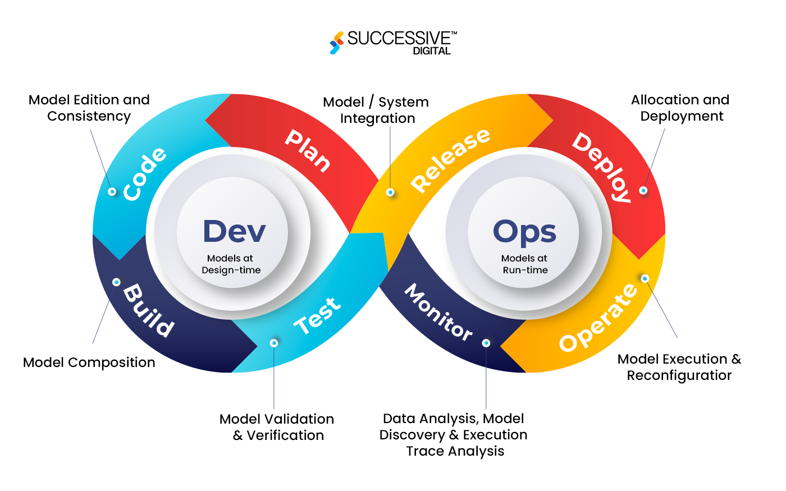

DevOps is a cultural and practical approach that integrates software development (Dev) and IT operations (Ops) to streamline the software development lifecycle, fostering collaboration, automation, and continuous improvement, ultimately leading to faster, more reliable software delivery.

**What is DevOps?**

DevOps combines practices, tools, and a cultural philosophy to automate and integrate processes between software development and IT operations teams.

It's not just about tools, but also about a culture of collaboration, shared responsibility, and continuous feedback.

DevOps aims to shorten the time between committing code and deploying it to production, while ensuring high quality.

**Significance in Modern Software Development and IT Operations:**

**Faster Time-to-Market:** DevOps enables organizations to deliver software and services faster, allowing them to respond quickly to changing market demands.

**Improved Quality and Reliability:** Automation and continuous feedback loops help identify and fix issues early in the development process, leading to higher quality and more reliable software.

**Enhanced Collaboration and Communication:** DevOps promotes collaboration between development and operations teams, breaking down silos and fostering a culture of shared responsibility.

**Increased Agility and Flexibility:** DevOps enables organizations to adapt quickly to changing requirements and market conditions, making them more agile and flexible.

**Cost Savings:** Automation and efficient processes can lead to reduced costs associated with software development and deployment.

**Addressing Challenges of Traditional Development and Operations:**

**Long Development Cycles:** Traditional methods often involve long development cycles, lengthy testing periods, and delayed deployments, which DevOps addresses through automation and continuous integration/continuous delivery (CI/CD).

**Lack of Collaboration and Communication:** Siloed development and operations teams can lead to communication breakdowns and delays. DevOps promotes collaboration and shared responsibility, breaking down these silos.

**Manual Processes and Errors:** Traditional methods often rely on manual processes, which are prone to errors and delays. DevOps automates these processes, reducing errors and improving efficiency.

**Difficulty in Adapting to Change:** Traditional methods can be inflexible and difficult to adapt to changing requirements. DevOps enables organizations to embrace agility and adapt quickly to changing conditions.

**Key DevOps Practices:**

**Continuous Integration (CI):** Developers frequently integrate their code changes into a shared repository, and automated tests are run to ensure that the code is working correctly.

**Continuous Delivery (CD):** Automated processes are used to build, test, and deploy software releases frequently and reliably.

**Infrastructure as Code (IaC):** Infrastructure is managed as code, allowing for automation and repeatability.

**Monitoring and Feedback:** Continuous monitoring of systems and applications provides valuable feedback for identifying and resolving issues.

**Automation:** Automating tasks like building, testing, and deployment reduces manual effort and improves efficiency.

Why is DevOps important?

• Faster delivery: It speeds up software releases.

• Better quality: Early testing and automation reduce errors.

• Teamwork: Developers and IT teams work together smoothly.

• Flexibility: Makes it easy to adapt to changes.

• Cost savings: Automation reduces effort and costs.

How does DevOps solve old problems?

• Long processes → Automates and speeds things up.

• Poor communication → Encourages teamwork.

• Manual errors → Uses automation for accuracy.

• Slow adaptability → Helps teams adjust quickly.

Key DevOps practices:

• Continuous Integration (CI): Frequent code updates with automatic testing.

• Continuous Delivery (CD): Automated build and deployment.

• Infrastructure as Code (IaC): Managing resources through code.

• Monitoring & Feedback: Constantly checking for issues.

• Automation: Reduces manual work.

**Evolution and Key Principles:**

Q2)Imagine software development as a past factory assembly line. How has the industry evolved to embrace DevOps principles, and what are the key principles and goals of DevOps? How do these principles drive DevOps methodologies?

If we think of traditional software development like a past factory assembly line, where each stage (coding, testing, deployment) is a separate station with limited communication between them, DevOps represents a complete overhaul, moving towards a highly automated, collaborative production line where developers and operations teams work seamlessly together to rapidly deliver high-quality software, much like a modern, flexible manufacturing facility with real-time feedback loops.

Key DevOps Principles and Goals:

**Collaboration:**

Breaking down silos between development and operations teams, fostering a culture where everyone shares responsibility for the entire software lifecycle, just as different stations on an assembly line work together to build a product.

**Automation:**

Automating repetitive tasks like building, testing, deployment, and infrastructure provisioning, eliminating manual errors and enabling faster delivery cycles, similar to robotic arms on a factory line performing tasks consistently.

**Continuous Integration (CI):**

Regularly integrating code changes into a shared repository, allowing for frequent testing and early detection of issues, like having quality checks at every stage of the assembly line.

**Continuous Delivery (CD):**

Automatically deploying new code to production environments quickly and reliably, ensuring new features reach users rapidly, akin to a streamlined conveyor belt moving finished products to the packaging stage.

**Continuous Monitoring:**

Real-time monitoring of application performance and health, allowing for immediate detection and response to issues, like sensors on a production line monitoring for potential problems.

**Feedback Loops:**

Incorporating feedback from users and operations teams back into the development process to continuously improve software quality, similar to a quality control loop on a factory floor.

How DevOps Principles Drive Methodologies:

**Agile Development:**

DevOps often leverages agile principles like iterative development and flexible planning to quickly adapt to changing requirements and deliver value incrementally.

**Infrastructure as Code (IaC):**

Managing infrastructure through code, allowing for consistent provisioning and rapid scaling of environments, like a programmable assembly line that can adjust capacity based on demand.

**Containerization:**

Utilizing container technologies (e.g., Docker) to package applications with their dependencies, enabling consistent deployment across different environments, like standardized parts on a production line.

**Microservices Architecture:**

Breaking down applications into smaller, independently deployable services, which can be developed, tested, and deployed separately, like modular components on an assembly line.

Overall, DevOps shifts the software development paradigm from a slow, linear process to a continuous, automated, and collaborative approach, enabling organizations to deliver software faster, more reliably, and with greater adaptability to market needs, much like a modern manufacturing plant with advanced automation and integrated feedback systems.

Simplifying DevOps Principles:

* **Teamwork**: Developers and IT teams work together instead of separately.
* **Automation**: Repetitive tasks like testing and deployment happen automatically.
* **Continuous Integration (CI)**: Code updates are tested frequently, catching issues early.
* **Continuous Delivery (CD)**: New features are deployed quickly and reliably.
* **Monitoring & Feedback**: Systems are constantly checked, and improvements are made in real time.

How DevOps Methods Work:

* **Agile Development**:Software is built in small, fast updates rather than big, slow releases.
* **Infrastructure as Code (IaC)**: IT setup is managed through code for consistency.
* **Containerization**: Apps are packaged with everything they need to run smoothly anywhere.
* **Microservices**: Apps are broken into smaller parts for flexibility and faster updates.

**Benefits and Challenges of Implementation:**

Q3) Your team considers adopting DevOps. Write potential benefits (faster releases, improved quality) and challenges (cultural shift, tooling complexity) of implementing DevOps.

When considering a DevOps adoption, your team could potentially see significant benefits like faster release cycles, improved software quality, and increased efficiency, but must also be prepared to address challenges like a cultural shift within the organization and the complexity of integrating new tooling across different teams.

Potential Benefits of DevOps:

**Faster Releases:**

Continuous Integration and Continuous Delivery (CI/CD) pipelines automate the build, test, and deployment process, drastically reducing time to market for new features and updates.

Frequent small releases allow for rapid iteration and quicker response to customer feedback.

**Improved Quality:**

Automated testing at every stage of the development process catches bugs early, leading to higher quality software with fewer post-release issues.

Continuous monitoring provides real-time insights into system health, enabling proactive identification and resolution of problems.

**Enhanced Collaboration:**

Breaking down silos between development and operations teams fosters better communication and shared responsibility throughout the software lifecycle.

Cross-functional teams work together to identify and address issues more efficiently.

**Increased Efficiency:**

Automation of repetitive tasks frees up team members to focus on more strategic work.

Streamlined processes reduce manual intervention, minimizing errors and improving overall productivity.

**Scalability:**

Infrastructure as Code (IaC) enables rapid provisioning and scaling of resources to meet fluctuating demand.

Easier adaptation to changing business requirements.

Potential Challenges of DevOps Implementation:

**Cultural Shift:**

Overcoming resistance to change from teams accustomed to traditional development and operations practices.

Establishing a culture of shared ownership, collaboration, and continuous improvement across the organization.

**Tooling Complexity:**

Selecting and integrating a wide range of DevOps tools for source control, CI/CD, monitoring, logging, etc.

Learning curve for team members to effectively utilize new tools and technologies.

**Skillset Requirements:**

Need for developers and operations staff to acquire new skills in automation, cloud computing, and monitoring.

Training and upskilling programs may be necessary to support the transition.

**Security Concerns:**

Integrating security practices into the DevOps pipeline to ensure secure deployments.

Addressing potential vulnerabilities introduced by rapid development cycles.

**Infrastructure Challenges:**

Migrating existing systems to a cloud-based infrastructure or adapting on-premise infrastructure to support DevOps practices.

Potential disruption during the transition process.

**DevOps Engineer Skillset:**

Q4)You're interviewing for a DevOps engineer position. Describe the essential skillset required, including scripting languages, version control systems, and CI/CD pipeline understanding. Draw a mindmap for skillsets."

**System Administration:**

Linux/Unix Shell Scripting (Bash, Zsh)

Windows PowerShell

System administration on Linux distributions (Ubuntu, CentOS)

Network fundamentals

Security best practices

Troubleshooting system issues

**Coding & Scripting:**

Python (most common for automation)

Ruby (for automation with tools like Chef)

Go (for high-performance systems)

JavaScript (for web-based automation)

**Version Control:**

Git (essential for code management)

Understanding of branching strategies (feature, hotfix, etc.)

Git commands (clone, add, commit, push, pull)

**Configuration Management:**

Ansible (declarative approach)

Puppet (imperative approach)

Chef (infrastructure as code)

Terraform (cloud infrastructure provisioning)

**Containerization:**

Docker (container creation and management)

Kubernetes (container orchestration)

**CI/CD Pipeline:**

Jenkins

GitLab CI/CD

CircleCI

Understanding pipeline stages (build, test, deploy)

**Cloud Computing:**

AWS (Amazon Web Services)

Azure

GCP (Google Cloud Platform)

Cloud resource management

Soft Skills:

**Communication:**

Clear and concise communication with developers, testers, and other stakeholders

Ability to articulate technical concepts to non-technical audiences

**Collaboration:**

Teamwork and ability to work effectively within cross-functional teams

Agile methodologies

**Problem-Solving:**

Analytical skills to diagnose and troubleshoot complex system issues

Ability to think critically and come up with creative solutions

**Adaptability:**

Willingness to learn new technologies and stay updated with industry trends

Key Points:

**Strong foundation in Linux:**

Most DevOps work is done on Linux systems, so proficiency in Linux commands and system administration is crucial.

**Scripting expertise:**

Scripting languages like Python are essential for automating repetitive tasks and managing infrastructure.

**Version control understanding:**

Git is the industry standard for code management, and a DevOps engineer needs to be comfortable with its functionalities.

**CI/CD pipeline knowledge:**

Understanding how to set up and manage automated build, test, and deployment pipelines is vital.

**Cloud familiarity:**

Most organizations are moving to the cloud, so familiarity with major cloud providers is beneficial.

**Soft skills are important:**

Effective communication and collaboration are key for a DevOps engineer to work effectively with different teams.

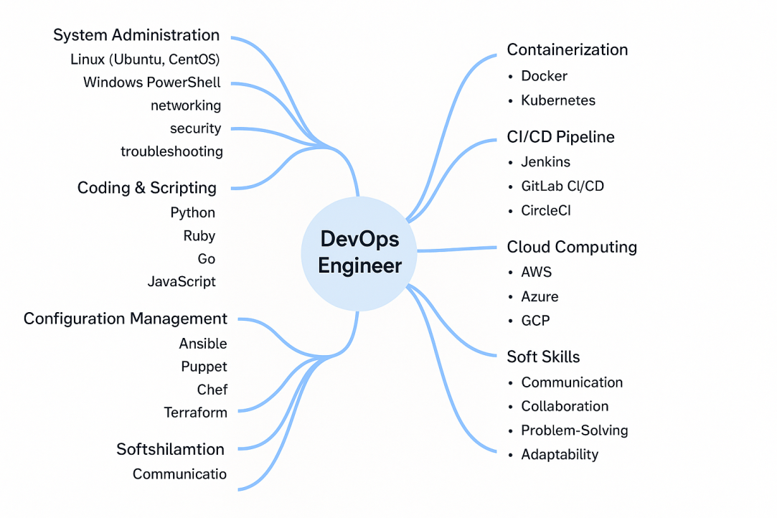

Q5)Imagine a DevOps engineer facing a production outage. What common challenges might they encounter (limited visibility, lack of automation) and how can they overcome them? Draw a mindmap for above.

**Challenges & Solutions in System Monitoring and Automation**

**1. Monitoring Issues**

* **Incomplete Data:** Some system layers are not being tracked.
  + **Solution:** Use monitoring tools that cover all aspects—application, network, infrastructure.
* **No Real-time Alerts:** System issues aren't detected quickly.
  + **Solution:** Set up alerts that notify instantly when problems arise, using smart detection.

**2. Problems Due to Lack of Automation**

* **Manual Troubleshooting:** Finding errors takes too much time.
  + **Solution:** Automate basic fixes, log checks, and system analysis.
* **Slow Rollbacks:** Reverting system changes is slow.
  + **Solution:** Use automatic rollback processes to restore stable versions quickly.
* **Manual Deployments:** Software updates take extra effort.
  + **Solution:** Use CI/CD pipelines for smooth automatic deployments with testing.

**3. Other Challenges**

* **Complex System Design:** Hard to understand relationships between parts.
  + **Solution:** Keep clear documentation and use tracing tools to find slow points.
* **Poor Documentation:** System details are missing or unclear.
  + **Solution:** Maintain well-organized records of components, setups, and fixes.
* **Lack of Teamwork:** Developers, operations, and security teams don’t collaborate well.
  + **Solution:** Improve communication and encourage shared responsibility.

**4. Steps to Overcome Challenges**

* **Better Monitoring & Alerts:** Spot issues early and prioritize warnings based on urgency.
* **Strong Incident Management:** Have clear steps for handling issues and learning from past errors.
* **Infrastructure as Code (IaC):** Use automation to standardize setups and enable quick recovery.
* **Chaos Engineering:** Test the system with controlled failures to make it stronger.

**5. Key Considerations**

* **Tool Integration:** Connect monitoring, alerting, and automation tools for a smooth experience.
* **Skill Development:** Train engineers in troubleshooting and response methods.
* **Culture of Improvement:** Always refine processes based on feedback and new insights.

**Cultural Transformation:**

Q6)Your development team is excited about DevOps, but the operations team is hesitant. Explain the importance of cultural transformation and strategies to promote shared ownership and collaboration."

To successfully implement DevOps, a cultural transformation is crucial, especially when the operations team is hesitant, as it requires a shift towards shared ownership and collaboration between development and operations, breaking down traditional silos and fostering a unified approach to software delivery.

Why Cultural Transformation Matters:

**Shared Responsibility:**

DevOps is not just about tools, it's about a mind-set where both development and operations teams are accountable for the entire software lifecycle, from design to deployment and monitoring, leading to better quality and faster resolution of issues.

**Improved Communication:**

By fostering open communication and transparency, teams can proactively identify potential problems and collaborate effectively to resolve them.

**Faster Feedback Loops:**

A collaborative environment allows for rapid feedback between teams, enabling quicker iterations and continuous improvement.

**Increased Efficiency:**

Breaking down silos and streamlining processes can significantly improve overall efficiency and time to market.

Strategies to Promote Shared Ownership and Collaboration:

**Leadership Buy-In:**

Executive leadership must actively champion the DevOps culture, communicating its value and providing necessary support for change.

**Cross-functional Training:**

Provide training to both development and operations teams on DevOps principles, tools, and each other's roles to bridge the knowledge gap and build empathy.

**Joint Team Projects:**

Involve both teams in small, collaborative projects early on to demonstrate the benefits of working together and build trust.

**Shared Performance Metrics:**

Establish shared success metrics that incentivize collaborative behavior and align team goals towards overall system health.

**Regular Communication Channels:**

Facilitate open communication through regular meetings, team-wide updates, and readily accessible collaboration platforms.

**"You Build It, You Run It" Principle:**

Encourage developers to take ownership of their applications in production by actively participating in monitoring and troubleshooting.

**Promote a Learning Culture:**

Foster an environment where continuous learning is encouraged, allowing teams to share knowledge and adapt to evolving technologies.

Addressing Operations Team Concerns:

**Security and Stability Focus:**

Assure the operations team that DevOps does not compromise security or stability, and emphasize the importance of incorporating security practices throughout the development process.

**Gradual Change Management:**

Implement new practices in a phased manner, allowing the operations team to adjust and become comfortable with the new workflow.

**Acknowledge Existing Expertise:**

Value the operational expertise of the team and provide opportunities for them to contribute their knowledge to the DevOps process.

By prioritizing cultural transformation and actively engaging the operations team, organizations can successfully adopt DevOps practices, leading to faster delivery cycles, improved software quality, and a more efficient development process.

DevOps & Cultural Transformation: Why It Matters

To make DevOps work, teams—especially operations—need to change how they think and work together. DevOps is about shared responsibility, where development and operations teams collaborate instead of working separately. This helps with:

• Better teamwork: Developers and operations work side by side, improving software quality.

• Faster fixes: Quick feedback loops allow issues to be solved quickly.

• Efficiency: No more silos—streamlining processes speeds up delivery.

How to Build a Collaborative DevOps Culture

• Leadership Support: Leaders must back the change and promote its benefits.

• Training Across Teams: Developers learn operations skills, and vice versa, to understand each other’s roles.

• Joint Projects: Small collaborative projects show teams the value of working together.

• Shared Goals & Metrics: Success is measured by system health, not just individual tasks.

• Open Communication: Regular team meetings and easy-to-use collaboration tools help.

• Developers Take Ownership: The "You Build It, You Run It" mindset ensures developers help with monitoring.

Helping the Operations Team Adapt

• Focus on Security & Stability: Show that DevOps keeps systems secure.

• Gradual Changes: Introduce new practices step by step to avoid overwhelm.• Respect Experience: Operations teams bring valuable expertise—let them contribute to DevOps decisions.

**CI/CD Significance:**

Q7)Your team wants to automate unit testing as part of the CI pipeline. Explain the significance of CI/CD and how automating tests can improve software quality."

CI/CD (Continuous Integration and Continuous Delivery) is a software development practice that involves frequently integrating code changes into a shared repository and automatically building, testing, and deploying them, ensuring rapid feedback loops and enabling faster release cycles. By automating unit tests within the CI pipeline, teams can significantly improve software quality by catching potential issues early in the development process, leading to quicker bug fixes and more reliable releases.

Key benefits of automating unit tests in a CI pipeline:

**Early Bug Detection:**

Running unit tests automatically after every code commit allows developers to identify and address bugs as soon as they are introduced, preventing them from accumulating and causing larger problems later in the development cycle.

**Faster Feedback Loop:**

Automated tests provide immediate feedback to developers about the quality of their code, allowing them to quickly fix issues while the changes are still fresh in their minds.

**Increased Test Coverage:**

By automating tests, developers are more likely to write comprehensive test suites covering various scenarios, leading to better overall code quality.

**Regression Prevention:**

When new code is integrated into the main codebase, automated tests can quickly identify regressions, ensuring that existing features are not unintentionally broken.

**Improved Team Collaboration:**

With automated tests running consistently, developers and testers can collaborate more effectively by having clear visibility into the current state of the codebase.

How it works in practice:

**CI Server Integration:**

The CI server (like Jenkins, GitHub Actions, or CircleCI) is configured to trigger unit tests automatically whenever a developer commits code to the repository.

**Test Execution:**

The CI server runs the automated unit tests on the newly integrated code, generating detailed reports on test results.

**Feedback Mechanism:**

If any tests fail, the CI server alerts the developer immediately, allowing them to quickly address the issues before moving forward.

Important considerations for effective unit testing automation:

**Test Design:**

Create well-structured and isolated unit tests that target specific functionalities of the code.

**Test Coverage:**

Aim for high test coverage to ensure that most code paths are exercised by the tests.

**Test Maintainability:**

Write clean and reusable tests to facilitate future updates and changes to the codebase.

.

**Automation and IaC:**

Q8)Imagine a tedious manual configuration process for new development environments. Provide an example of automation applied in a DevOps environment, like IaC, and explain how it can improve efficiency and consistency. Also analyse the role of IaC in multiple server deployments

A typical manual development environment setup might involve tasks like manually creating virtual machines, installing operating systems, configuring network settings, setting up databases, deploying application code, and manually adjusting firewall rules, which can be time-consuming, prone to errors, and inconsistent across different environments.

Automation with IaC (Infrastructure as Code):

**Example:** Using a tool like Terraform, a developer can write a configuration file (like a "terraform.tf" file) that defines all the necessary infrastructure components (servers, networks, security groups, databases) with their desired configurations, essentially describing the environment in code. This file can then be executed to automatically provision the entire environment on any cloud platform.

**How IaC improves efficiency and consistency:**

**Reduced Manual Effort:**

By code infrastructure setup, developers no longer need to perform repetitive manual tasks, freeing up time to focus on application development.

**Reproducible Environments:**

Since the environment is defined in code, it can be easily replicated across different development stages (dev, staging, production) ensuring consistency.

**Version Control:**

IaC can be stored in a version control system, enabling tracking of changes to infrastructure configurations and rollback capabilities in case of issues.

**Faster Deployment:**

Automated provisioning with IaC significantly reduces the time required to set up a new development environment.

**Error Reduction:**

By eliminating manual intervention, IaC minimizes the risk of human errors that can occur during configuration.

**Role of IaC in Multiple Server Deployment:**

**Scalability:**

When deploying across multiple servers, IaC allows for easy scaling by modifying the configuration file to add or remove necessary infrastructure components as needed.

**Blue/Green Deployment:**

IaC can be used to implement blue/green deployments, where a new version of the application is deployed on a separate set of servers, allowing for seamless switchover with minimal downtime.

**Environment Consistency:**

IaC ensures that all environments (dev, staging, production) are configured identically, minimizing discrepancies and potential issues during deployment.

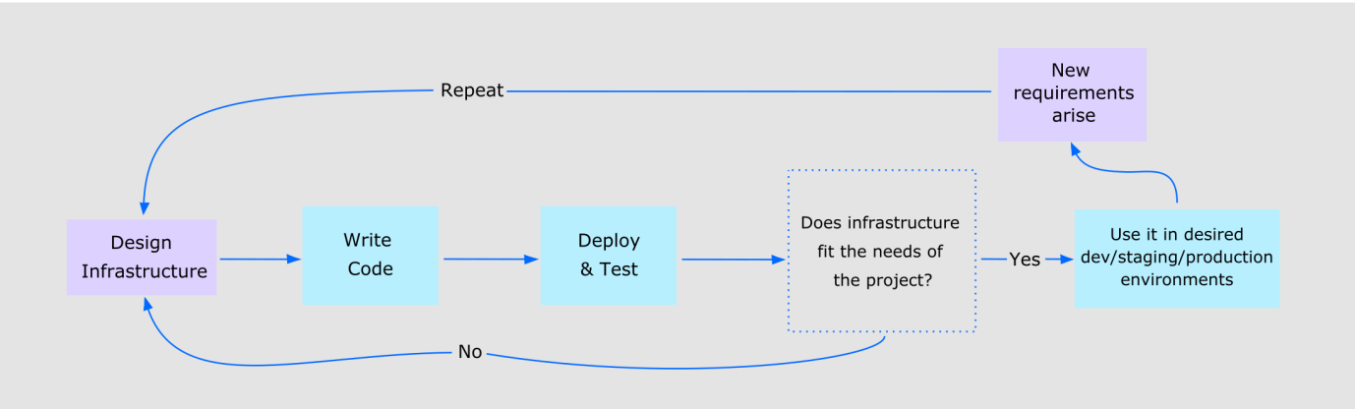

**DevOps vs. Traditional IT Operations:**

Q9)Compare and contrast traditional IT operations with DevOps practices, focusing on areas such as deployment frequency, lead time for changes, and mean time to recovery (MTTR). How does DevOps improve upon traditional methodologies?

DevOps improves upon traditional IT operations by fostering collaboration, automating processes, and accelerating delivery, leading to faster deployment frequencies, shorter lead times for changes, and quicker mean time to recovery (MTTR).

|  |  |  |
| --- | --- | --- |
| Aspect | Traditional IT Operations | DevOps Practices |
| Deployment Frequency | Low, with fewer, scheduled deployments (weekly, monthly, etc.) | High, with multiple deployments per day possible |
| Lead Time for Changes | Longer, due to manual processes and siloed (of a system, process, department, etc.) isolated from others.) teams | Shorter, through automation and cross-functional collaboration |
| Mean Time to Recovery (MTTR) | Longer, as failures are addressed after deployment | Shorter, through continuous monitoring, automated deployments, and quick feedback loops |
| Team Structure | Separate teams for development, testing, and deployment, creating silos | Cross-functional teams that handle development, testing, and deployment together |
| Risk Management | Risks are managed at release stages, often leading to larger changes and higher impact if issues arise | Continuous testing and monitoring reduce risk over time |
| Collaboration | Limited collaboration between development and operations teams | Strong collaboration and shared responsibility between development and operations teams |
| Automation | Manual processes and limited automation | Extensive automation of tasks like testing, deployment, and infrastructure management |
| Focus | Maintaining infrastructure and ensuring software runs smoothly | Accelerating delivery, improving software quality, and fostering a culture of continuous learning and innovation |

**Impact of Cultural Shift:**

Q10)Your organization is undergoing a cultural shift towards DevOps practices. As a team lead, evaluate the impact of this cultural shift on collaboration within your software development team. Explain how fostering a culture of shared responsibility influences the overall effectiveness of the development and deployment lifecycle.

**How DevOps Improves Team Collaboration**

DevOps is a way of working that helps software development teams work better together. It brings development and operations teams closer by sharing responsibility for the whole process—from writing code to testing, deploying, and monitoring it. This leads to faster feedback, better teamwork, and higher-quality software.

**Key Ways DevOps Improves Collaboration:**

**1. Breaking Down Silos:**  
DevOps removes the barriers between development and operations teams. Everyone works together, understands the whole system, and solves problems more easily.

**2. Continuous Feedback:**  
Automated testing and monitoring give quick feedback on code changes. Developers can fix problems faster and improve the product quickly.

**3. Shared Ownership:**  
Everyone on the team is responsible for the product's success. This increases accountability and teamwork.

**4. Better Communication:**  
Regular meetings, shared dashboards, and communication tools keep everyone updated on the project's progress and challenges.

**5. Empowerment and Autonomy:**  
Teams are encouraged to take ownership and make decisions on their own. This builds motivation and helps improve how things are done.

**How Shared Responsibility Helps the Development Process:**

* **Faster Delivery:** Automation helps teams release new features quickly.
* **Fewer Mistakes:** Continuous testing finds problems early, reducing bugs.
* **More Reliable Systems:** Monitoring helps fix issues before users are affected.
* **Happier Customers:** High-quality software delivered quickly leads to better customer satisfaction.

**Tips to Build a Culture of Shared Responsibility:**

* **Cross-Training:** Teach team members skills from other roles, like developers learning about operations.
* **Blameless Postmortems:** When things go wrong, analyze the issue together without blaming anyone.
* **Team-Based Goals:** Focus on team achievements, not just individual success.
* **Open Communication:** Create a safe space where everyone can speak up and give feedback.
* **Support from Leaders:** Leaders should support DevOps practices and give the team what they need to succeed.

**UNIT 2**

**Q1)Explain branching and merging strategies in Git, including their advantages and challenges, and how they contribute to effective collaboration and code management.** (This covers Git basics and advanced collaboration.)

**Branching in Git**

Branching allows developers to work on different versions of the code independently. It ensures that new features or fixes can be developed without affecting the main codebase.

**Common Branching Strategies**

1. **Feature Branching** – Developers create a branch for each feature. Once the feature is complete, they merge it back into the main branch.
   * *Advantages:* Keeps the main codebase clean and stable while developing new features.
   * *Challenges:* Managing many branches can become complex.
2. **Git Flow** – A structured approach using multiple branches like main, develop, feature, release, and hotfix.
   * *Advantages:* Well-suited for large teams with a clear process for releases.
   * *Challenges:* Can be complicated and slow for small teams.
3. **Trunk-Based Development** – Developers work on short-lived branches and merge frequently into the main branch.
   * *Advantages:* Enables faster development and integration.
   * *Challenges:* Requires careful coordination to prevent issues.

**Merging in Git**

Once a branch is complete, it needs to be merged into the main codebase. This integrates the changes into the shared repository.

**Common Merging Strategies**

1. **Fast-forward Merge** – If no new commits exist on the main branch, Git simply moves the pointer forward.
   * *Advantages:* Keeps history clean.
   * *Challenges:* Does not preserve branching history.
2. **Three-way Merge** – When multiple branches have diverged, Git creates a new merge commit.
   * *Advantages:* Maintains history of all merged changes.
   * *Challenges:* May cause conflicts that require manual resolution.
3. **Rebase** – Moves branch changes on top of the latest main branch updates.
   * *Advantages:* Creates a cleaner commit history.
   * *Challenges:* Can be risky if not done carefully.

**How They Improve Collaboration & Code Management**

* **Parallel Development:** Teams can work on multiple features simultaneously.
* **Risk Reduction:** Bugs or issues in a branch don’t affect the main codebase.
* **Code Review:** Ensures quality before changes are merged.
* **Organized Code History:** Keeps commit history clear and meaningful.

Choosing the right strategy depends on the project size, complexity, and workflow. A well-managed branching and merging approach ensures smoother collaboration and stable code development. Let me know if you need further explanations.

**Q2)Describe the steps involved in collaborating with a team member using Git and GitHub, including relevant commands and best practices for smooth coordination and code integration.** (This focuses on practical Git/GitHub usage.)

Collaborating with a team member using Git and GitHub involves several steps, ensuring smooth coordination and code integration. Here’s a practical guide:

**Step 1: Set Up Git and GitHub**

* Install Git: If you haven't already, download and install Git from [git-scm.com](https://git-scm.com).
* Configure Git with your identity:
* git config --global user.name "Your Name"
* git config --global user.email "your-email@example.com"
* Create a GitHub account and generate an SSH key (if using SSH).

**Step 2: Clone the Repository**

If your team has an existing repository on GitHub, clone it to your local machine:

git clone <repository-url>

**Step 3: Create a Branch for Your Changes**

Working on a separate branch prevents conflicts with the main branch.

git checkout -b feature-branch

Best Practice: Use descriptive branch names (e.g., fix-login-bug, add-dashboard).

**Step 4: Make Changes and Commit**

Edit your files and add them to the staging area:

git add .

Commit your changes with a meaningful message:

git commit -m "Added new feature to dashboard"

**Step 5: Push Changes to GitHub**

Upload your branch to the remote repository:

git push origin feature-branch

**Step 6: Create a Pull Request**

* Go to the GitHub repository.
* Click on "Pull Requests" → "New Pull Request."
* Select your feature branch and compare it with the main branch.
* Add a clear title and description, then submit the request.

**Step 7: Review and Merge**

* Team members review the pull request and provide feedback.
* Resolve conflicts if necessary:
* git merge main
* Merge the pull request into the main branch on GitHub.

**Step 8: Sync Local Repository**

After merging, update your local repository:

git checkout main

git pull origin main

**Q3)Explain the core concepts of Spring and Spring Boot, differentiating between them and outlining scenarios where Spring Boot is preferred. Also, describe the role of Hibernate in a Java application and its core functionalities.** (This covers essential Java frameworks.)

**Spring vs. Spring Boot: Core Concepts and Differences**

|  |  |  |
| --- | --- | --- |
| Feature | Spring | Spring Boot |
| Setup | Needs manual XML or Java setup | Automatically sets things up |
| Dependencies | Must select required tools manually | Comes with ready-to-use toolkits |
| Web Server | Needs extra setup for a server | Has built-in servers like Tomcat |
| Microservices | Can be used but needs extra steps | Designed for microservices |
| Startup Speed | Slower because of configurations | Faster due to automatic setup |
| Development Speed | More work before coding starts | Makes coding faster and easier |
| Best Use | Good for big, complex apps | Perfect for microservices and cloud apps |

**1. Spring Configuration Example (Manual Setup)**

In traditional **Spring**, we need XML or Java-based configuration for dependency injection

<beans xmlns="http://www.springframework.org/schema/beans"

xmlns:xsi="http://www.w3.org/2001/XMLSchema-instance"

xsi:schemaLocation="http://www.springframework.org/schema/beans

http://www.springframework.org/schema/beans/spring-beans.xsd">

<bean id="helloService" class="com.example.HelloService"/>

</beans>

### Java-Based Configuration (Spring)

@Configuration

public class AppConfig {

@Bean

public HelloService helloService() {

return new HelloService();

}

}

Top of Form

Bottom of Form

**2. Spring Boot Example (Auto-Configured)**

Spring Boot eliminates boilerplate configuration and provides default setups.

**Spring Boot Application Class**

@SpringBootApplication

public class SpringBootExample {

public static void main(String[] args) {

SpringApplication.run(SpringBootExample.class, args);

}

}

**REST Controller Example in Spring Boot**

@RestController

@RequestMapping("/api")

public class HelloController {

@GetMapping("/hello")

public String sayHello() {

return "Hello, Spring Boot!";

}

}

* Spring Boot **automatically configures** components, removing the need for manual XML setup.
* The **@SpringBootApplication** annotation sets up the application.
* The **@RestController** simplifies web API development.

**: Role and Key Features**

Hibernate is an **Object-Relational Mapping (ORM)** tool that helps Java applications interact with databases easily, without needing complex SQL queries.

**Why Use Hibernate in Java?**

* **Simplifies Database Access** – Maps Java objects to database records automatically.
* **Improves Maintainability** – Reduces the need for writing SQL manually.
* **Enhances Performance** – Uses caching to speed up queries and reduce database load.

**Main Features of Hibernate**

1. **ORM Mapping** – Converts Java objects into database tables using annotations or XML.
2. **Hibernate Query Language (HQL)** – Allows developers to write database queries using Java-like syntax.
3. **Transaction Management** – Ensures safe data handling with ACID compliance.
4. **Lazy Loading** – Loads data only when needed, improving efficiency.
5. **Caching** – Minimizes database calls, improving application speed.

**Q4)Outline the key stages involved in developing an e-commerce web application using a DevOps approach, and explain how to integrate at least two DevOps principles (e.g., CI/CD, automation) into each stage.** (This ties Java development to DevOps principles.)

Developing an e-commerce web application using a **DevOps approach** involves several stages, ensuring smooth development, deployment, and maintenance. DevOps principles like **Continuous Integration/Continuous Deployment (CI/CD), automation, monitoring, and collaboration** enhance efficiency at each step.

**1. Planning & Requirement Analysis**

This is the starting phase where you decide:

* What features the app will have,
* How the system will be built,
* What tools and technologies you'll use.

**How DevOps Helps:**

* **Automation:** Tools like **Terraform** or **AWS CloudFormation** can automatically set up your cloud environment—no need to do it manually.
* **Team Collaboration:** Tools like **Jira** and **Confluence** help teams stay organized and track tasks easily.

**2. Development & Version Control**

Here, developers write the code for the app using Java and Spring Boot. They build the app in smaller services (called **microservices**) that work together.

**How DevOps Helps:**

* **CI (Continuous Integration):** Tools like **GitHub Actions** or **Jenkins** automatically build and test the code every time someone makes a change.
* **Version Control:** Using **Git** (with strategies like **Git Flow**) helps developers work on different features without conflicts.

**3. Testing & Quality Assurance**

This stage ensures the app works correctly by testing parts of the code and how they work together.

**How DevOps Helps:**

* **Automated Testing:** Use tools like **JUnit**, **Selenium**, or **TestNG** to test code automatically, which saves time.
* **CI/CD Pipelines:** These pipelines ensure tests run automatically before the app goes live.

**4. Deployment & Release Management**

Now it's time to release the app to the users. You package it and send it to cloud servers.

**How DevOps Helps:**

* **CD (Continuous Deployment):** Tools like **Docker**, **Kubernetes**, and **Helm** automatically deploy the app.
* **Infrastructure Automation:** Tools like **Ansible** or **Terraform** help set up servers and services automatically.

**5. Monitoring & Security**

Once live, you need to make sure the app is running smoothly and is secure.

**How DevOps Helps:**

* **Monitoring:** Tools like **Prometheus** and **Grafana** help watch how the app performs and alert if anything goes wrong.
* **Security Checks:** Tools like **SonarQube** and **OWASP ZAP** automatically scan the app for security issues.

**Q5)Describe the development phase tools and technologies used in a new project, emphasizing DevOps practices, and how agile methodologies (e.g., Scrum) can be used to manage development tasks.** (This covers the development workflow and tools.)

**Development Phase: Tools, Technologies & Agile in DevOps**

When starting a new software project, using the right tools and methods makes development faster and smoother. DevOps focuses on automation and teamwork. Agile methods like **Scrum** help teams manage tasks and work better together.

**Key Tools & Technologies in DevOps Development**

**1. Version Control & Team Collaboration**

* **Git** – Keeps track of code changes.
* **GitHub, GitLab, Bitbucket** – Store code, allow team collaboration, and connect to automation tools.

**DevOps Practices:**

* Use **branching strategies** (like Git Flow) to organize development.
* Use **pull requests** to review code before adding it to the main branch.

**2. Continuous Integration & Deployment (CI/CD)**

* **Jenkins, GitHub Actions, GitLab CI/CD** – Automatically test and deploy code.
* **Docker & Kubernetes** – Run and manage apps in containers for easier scaling.

**DevOps Practices:**

* **Automated testing** helps find bugs early.
* **CI/CD pipelines** automate the process of combining code, testing it, and deploying it.

**3. Development & Build Tools**

* **VS Code, IntelliJ IDEA, Eclipse** – Tools where developers write code.
* **Maven & Gradle** – Manage project dependencies and build the app.
* **SonarQube** – Checks code for quality and security issues.

**DevOps Practices:**

* **Automated builds** reduce human error and speed up production.

**4. Monitoring & Logging**

* **Prometheus & Grafana** – Monitor system performance and health.
* **ELK Stack (Elasticsearch, Logstash, Kibana)** – Collect and display logs.
* **New Relic & Datadog** – Show real-time app performance.

**DevOps Practices:**

* **Automatic monitoring** catches problems early.
* **Log aggregation** helps find and fix issues quickly.

**Using Scrum (Agile Method) to Manage Work**

**Scrum** is a way to manage tasks in small steps so the team stays on track.

**1. Sprint Planning**

* Break work into short time periods called **sprints**.
* Plan sprint goals using tools like **Jira, Trello, or Azure DevOps**.

**DevOps Tip:**

* Link sprint boards with CI/CD tools to track what’s done.

**2. Daily Stand-ups**

* Short daily meetings to share progress and discuss issues.
* Use tools like **Slack, Teams, or Discord** for quick updates.

**DevOps Tip:**

* CI/CD can send automatic updates about which features are deployed.

**3. Code Review & Testing**

* Team members check each other’s code.
* Tools like **JUnit, Selenium, and Postman** run automatic tests.

**DevOps Tip:**

* Run tests automatically when new code is added.

**4. Retrospectives & Improvements**

* After each sprint, review what went well and what can be better.
* Use **Confluence or Notion** to write down the feedback.

**DevOps Tip:**

* Use **GitHub Issues or Jira** to track feedback and make improvements.

**Final Thoughts**

By combining DevOps tools with Scrum, teams can:

* Work better together
* Automate repetitive tasks
* Deliver high-quality software faster

**Q6)Evaluate strategies to improve communication and collaboration between Dev and Ops teams in a DevOps environment, and explain the importance of shared tooling and processes.** (This focuses on the collaboration aspect.)

**How Dev and Ops Teams Work Together in DevOps**

In DevOps, developers (Dev) and operations (Ops) teams need to communicate and work well together. This helps speed up software development and keep systems running smoothly.

**Ways to Improve Collaboration**

1. **Work as One Team** – Instead of separate groups, developers and operations should collaborate from the start.
2. **Use Shared Tools** – Both teams should use the same tools for version control, testing, and monitoring.
3. **Automate Processes** – Automate testing, deployment, and server management to reduce errors and save time.
4. **Continuous Feedback** – Use monitoring tools and alerts so both teams can quickly fix issues.
5. **Regular Meetings** – Short daily meetings help teams stay updated on problems and progress.

**Why Shared Tools Matter**

* Everyone follows the same process, making work easier.
* Developers can see performance data and fix problems faster.
* Automated tests and deployments reduce mistakes.
* Teams have better visibility into what’s happening.

**Q7)Justify the KPIs monitored during the operation phase of a project, and explain their role in project success and continuous improvement.** (This covers the operational aspects of DevOps.)

Key performance indicator

**Key Performance Indicators (KPIs) in the Operation Phase**

During the **operation phase** of a project, teams monitor KPIs to ensure stability, performance, and continuous improvement. These KPIs help identify problems early and optimize the system for better user experience and efficiency.

**1. System Performance KPIs**

**Response Time** – Measures how quickly the application responds to user actions.  
**CPU & Memory Usage** – Tracks system resource consumption to prevent overload.

*Role in Success:* Ensures the application is fast and reliable, leading to better user experience.  
 *Continuous Improvement:* Helps teams optimize code and infrastructure for better efficiency.

**2. Availability & Reliability KPIs**

**Uptime Percentage** – Tracks how often the system is available.  
**Mean Time Between Failures (MTBF)** – Measures how often unexpected failures occur.  
**Mean Time to Repair (MTTR)** – Shows how long it takes to fix an issue.

*Role in Success:* A highly available system improves customer trust and satisfaction.  
 *Continuous Improvement:* Helps teams refine processes for faster recovery from failures.

**3. Security & Compliance KPIs**

**Number of Security Incidents** – Tracks security breaches or vulnerabilities.  
**Patch & Update Compliance** – Ensures all security updates are applied on time.

*Role in Success:* Keeps user data safe and maintains trust.  
 *Continuous Improvement:* Helps refine security policies and automate patching.

**4. Deployment & Change Management KPIs**

**Deployment Frequency** – Shows how often new updates are released.  
**Change Failure Rate** – Measures how often new changes cause system issues.

*Role in Success:* Ensures smooth deployments with minimal disruptions.  
 *Continuous Improvement:* Helps teams improve release processes and reduce failures.

**5. User Experience & Satisfaction KPIs**

**Error Rate** – Tracks how often users encounter bugs or failed transactions.  
**User Feedback & Satisfaction Score** – Measures customer experience and sentiment.

*Role in Success:* Directly impacts how users interact with the system.  
*Continuous Improvement:* Helps prioritize fixes and enhancements that improve usability.

**Why These KPIs Matter in DevOps**

* Helps teams detect **issues early** and prevent failures.
* Supports **data-driven decision-making** for better efficiency.
* Ensures **continuous monitoring and optimization** for long-term success.

**Q8)Explain the significance of continuous integration and continuous delivery (CI/CD) in a DevOps pipeline, and describe the role of infrastructure as code (IaC) tools like Terraform. (This covers CI/CD and IaC, essential DevOps practices.)What is CI/CD?**

CI/CD stands for **Continuous Integration** and **Continuous Delivery (or Deployment)**. These practices help software teams automate development, testing, and deployment, making software updates faster and more reliable.

* **Continuous Integration (CI)** ensures new code is automatically tested when developers make changes. This prevents issues from accumulating and keeps the code stable.
* **Continuous Delivery (CD)** automates preparing the software for deployment, ensuring every change is tested and staged.
* **Continuous Deployment (CD)** goes a step further by automatically releasing software updates to users without manual steps.

**Why CI/CD Matters?**

* Reduces human errors in deployments.
* Speeds up the development process.
* Helps teams catch bugs early through automated testing.
* Ensures software updates are smooth and frequent.

**Role of Infrastructure as Code (IaC) in DevOps**

Infrastructure as Code (IaC) **automates the setup and management of cloud resources** using code instead of manual configurations.

* **Terraform** is a common tool that helps teams define cloud resources, like servers and networks, using configuration files.
* With IaC, cloud infrastructure is **consistent, scalable, and version-controlled**.
* It helps teams quickly deploy environments and make changes without manual intervention.

**Benefits of IaC:**

* Prevents configuration errors by using standardized settings.
* Improves security by tracking changes automatically.
* Saves time by allowing instant creation or modification of infrastructure.

**Q9)Explain how to leverage caching mechanisms (like Spring's caching support) to improve the performance of a web application. (This covers performance optimization in Java development.)**

**What is Caching?**

**Caching** is a technique to store frequently used data temporarily so that it can be accessed faster in future requests without needing to go to the database every time.

**Why Use Caching?**

1. **Faster Data Access**
   * Instead of going to the database, the application can fetch data directly from memory (which is much faster).
2. **Reduces Database Load**
   * By avoiding repeated database queries, it saves resources and reduces pressure on the server.
3. **Improves Application Performance**
   * Pages load faster, giving users a better experience.
4. **Helps in Scalability**
   * Less load on the server means the application can handle more users at once.

**Types of Caching**

1. **In-Memory Caching**
   * Data is stored in the application’s memory (RAM).
   * Fastest type of caching.
   * Suitable for single-server apps or data that doesn’t change often.
2. **Distributed Caching**
   * Cache is stored in external systems like **Redis** or **Memcached**.
   * Allows sharing the cache across multiple servers.
   * Good for large-scale or cloud-based applications.

**Spring Framework's Caching Support**

Spring provides easy tools to add caching to your Java app. Here’s how it helps:

1. **Simple to Enable**
   * Add @EnableCaching to your Spring Boot main class.
   * Example:
   * @SpringBootApplication
   * @EnableCaching
   * public class MyApp { ... }
2. **Use Annotations to Cache Methods**
   * Use @Cacheable on methods whose results should be stored.
   * Example:
   * @Cacheable("users")
   * public User getUserById(String id) {
   * return userRepository.findById(id);
   * }
   * When this method is called, it will check the cache first. If the result is already there, it skips the database call.
3. **Other Useful Annotations**
   * @CachePut: Updates the cache with the new result.
   * @CacheEvict: Removes entries from the cache (e.g., after data is updated or deleted).

**How Caching Works in Spring (Step-by-Step)**

1. Client requests data from the application.
2. Spring checks if the data is already stored in the cache.
3. If **yes** → return cached data (super fast!).
4. If **no** → call the method, get data from the database, and then store it in the cache for next time.

**Best Practices**

* Use caching for **read-heavy operations**.
* Avoid caching data that changes frequently.
* Set expiration times (TTL) to prevent stale data.
* Choose the right caching tool (memory vs. distributed) based on your app’s size and scale.

**Q10)Describe the steps for integrating Spring Security into a web application, including setting up authentication rules, defining user entities, and implementing login/logout functionality. (This covers security integration in Java applications.**

Spring Security **adds authentication and authorization** to web applications, ensuring that only authorized users can access certain features.

**Key Features of Spring Security:**

1. **Authentication:** Verifies user identity, usually through a username and password.
2. **Authorization:** Controls what actions or data a user can access based on their role (e.g., admin, regular user).
3. **Session Management:** Keeps track of logged-in users and prevents unauthorized access.

### 1. ****Add Spring Security to the Project****

**Theory**:

* Spring Security is not included by default.
* You must add it to the project to enable security features like authentication and authorization.

**Code (Maven)**:

<dependency>

<groupId>org.springframework.boot</groupId>

<artifactId>spring-boot-starter-security</artifactId>

</dependency>

### 2. ****Create a User Entity****

**Theory**:

* A user entity represents the user data stored in the database.
* It should include username, password, and role.

**Code**:

public class User {

private String username;

private String password;

private String role;

}

### 3. ****Implement UserDetailsService****

**Theory**:

* Spring uses this service to fetch user details from the database during login.
* It helps match the entered username/password with stored user data.

**Code**:

public class MyUserDetailsService implements UserDetailsService {

public UserDetails loadUserByUsername(String username) {

// Fetch user from database and return details

}

}

### 4. ****Configure Security Rules****

**Theory**:

* Set rules to control which user can access which URL.
* Define which paths are open, which require login, and which require specific roles.

**Code**:

@Configuration

public class SecurityConfig {

protected void configure(HttpSecurity http) throws Exception {

http

.authorizeRequests()

.antMatchers("/admin/**").hasRole("ADMIN")

.antMatchers("/user/**").hasAnyRole("USER", "ADMIN")

.antMatchers("/login", "/register").permitAll()

.anyRequest().authenticated()

.and()

.formLogin().loginPage("/login")

.and()

.logout();

}

}

### 5. ****Create Login Form****

**Theory**:

* Users need a login page to enter their username and password.
* The form posts data to Spring's default login handler (/login).

**Code (HTML)**:

<form method="post" action="/login">

<input type="text" name="username" />

<input type="password" name="password" />

<button type="submit">Login</button>

</form>

### 6. ****Enable Logout Functionality****

**Theory**:

* Spring Security handles logout with a default /logout endpoint.
* Logging out clears the session.

**Code (HTML)**:

<a href="/logout">Logout</a>

|  |  |
| --- | --- |
| Step | Description |
| 1 | Add Spring Security dependency to your project |
| 2 | Define a User entity with username, password, role |
| 3 | Implement UserDetailsService to load user info |
| 4 | Set authentication and authorization rules in config |
| 5 | Create a login form to accept user input |
| 6 | Use /logout to log users out of the system |

Let me know if you'd like a flowchart or short notes for revision!

**UNIT 3**

**Q1)Explain the purpose and core features of TestNG. Describe the steps involved in creating a TestNG JAR for a Java project.** (Covers TestNG's role and practical application.)

**Purpose of TestNG**

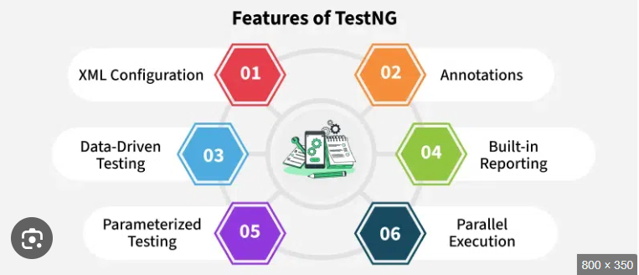

TestNG is a testing framework for Java that helps developers and testers run tests in an organized and efficient way. The "NG" in TestNG stands for "Next Generation" because it improves on older testing frameworks like JUnit.

It is mainly used for unit testing, integration testing, and functional testing of Java applications.

**Why Use TestNG?**

1. **Runs Tests Automatically** – You can run multiple test cases at once without manually checking each one.
2. **Better Reporting** – After running tests, TestNG creates a detailed report showing which tests passed, failed, or were skipped.
3. **Test Grouping** – You can organize tests into groups and run only specific groups when needed.
4. **Data-Driven Testing** – TestNG supports testing with different sets of data using the @Data Provider annotation.
5. **Parallel Testing** – It allows running multiple tests at the same time, making testing faster.
6. **Flexible Test Execution** – You can control the order of test execution and set dependencies between tests.

core features of TestNG:

1. **Annotations** – Special tags like @Test help define test cases and steps.
2. **Assertions** – Built-in checks to compare expected and actual results.
3. **Test Prioritization** – Lets you run important tests first.
4. **Parameterization** – Pass different test values without changing the code.
5. **Parallel Execution** – Run multiple tests at the same time to speed things up.
6. **XML Configuration** – Set up and manage tests easily using an XML file.

**Steps to Create a TestNG JAR for Java**

**Install TestNG** – Use Maven (add it in **pom.xml** or install it via Eclipse Marketplace

**Write Test Cases** – Create a Java class with **@Test** annotations.

**Create XML File** – Define test execution settings in **testng.xml**.

**Compile the Project** –

Run **javac -cp**

**testng.jar**

**MyTest.java**

**Create JAR** – Use **jar cf mytest.jar MyTest.class testng.xml.**

**Run the TestNG JAR** – Execute with

java -cp ;

testng.jar;

mytest.jar.

org.testng.TestNG testng.xml.

Q2)What is a Runnable/Fat JAR? Explain its significance in Java development, including simplified deployment, portability, and ease of execution. (Focuses on the practical benefits of Fat JARs.)

**What is a Runnable/Fat JAR?**

* **Runnable JAR** – A JAR file that contains a Java program with a main method. You can run it directly using java -jar filename.jar.
* **Fat JAR** – A special Runnable JAR that also includes all required libraries, so you don’t need to install dependencies separately.

## Practical Benefits of Using a Fat JAR

### 1. ****Ease of Execution****

* You can run your whole Java application with just:
* java -jar myapp-fat.jar
* No need to write long classpaths or install extra libraries.
* Simple and beginner-friendly way to run Java apps.

### 2. ****Simplified Deployment****

* All dependencies are included in one file.
* You don’t need to install or manage extra .jar files on the server or another computer.
* Great for deployment on servers, Docker containers, or cloud environments.

### 3. ****Portability****

* Fat JAR works on **any system with Java installed** (Windows, Linux, macOS).
* No need to worry about compatibility or missing files.
* Very useful when moving projects across teams, systems, or deployment environments.

### 4. ****Reduces Configuration Errors****

* Avoids problems like:
  + “ClassNotFoundException”
  + “NoClassDefFoundError”
* Since everything is already bundled, no missing dependencies.

### 5. ****Saves Time for Developers & DevOps****

* Only one file to build, test, and deploy.
* Works well with **CI/CD pipelines** and build automation tools.
* Easy to manage versions and releases.

### 6. ****Best Fit for Microservices****

* In microservice architecture, each service is small and independent.
* A Fat JAR makes each service self-contained and ready to deploy.
* Perfect for cloud environments (like AWS, Azure, GCP, etc.)

### 7. ****Useful for Testing and Demos****

* You can quickly create a Fat JAR and share it with someone else for testing.
* No need to send source code or tell them how to set up the environment.

## Tools to Create Fat JARs

* **Maven**: Use the maven-shade-plugin to bundle all dependencies.
* **Gradle**: Use the shadow plugin to create a Fat JAR.

### Example with Maven:

<plugin>

<groupId>org.apache.maven.plugins</groupId>

<artifactId>maven-shade-plugin</artifactId>

<version>3.2.4</version>

<executions>

<execution>

<phase>package</phase>

<goals><goal>shade</goal></goals>

<configuration>

<transformers>

<transformer implementation="org.apache.maven.plugins.shade.resource.ManifestResourceTransformer">

<mainClass>com.example.Main</mainClass>

</transformer>

</transformers>

</configuration>

</execution>

</executions>

</plugin>

**Q3)Describe how Maven handles dependency management in Java projects. What are the benefits of adding dependencies via Maven compared to adding JAR files manually?** (Covers a key Maven functionality and its advantages.)

**How Maven Handles Dependency Management in Java Projects**

Maven is a powerful **build automation tool** for Java projects. One of its most important features is **dependency management**, which helps developers automatically download and manage external libraries (JAR files) required for a project.

Instead of manually searching for, downloading, and adding JAR files, **Maven fetches dependencies automatically** from an online repository when you build your project.

**How Dependency Management Works in Maven**

1. **Define Dependencies in pom.xml**
   * Every Maven project has a pom.xml (Project Object Model) file.
   * You list the dependencies in this file, specifying the group ID, artifact ID, and version.
2. **Automatic Download from Maven Central Repository**
   * Maven checks its **local repository** (your computer).
   * If the required JAR file is not found, Maven downloads it from the **Maven Central Repository (online repository)**.
   * It saves the JAR in your local repository so that it does not need to be downloaded again.
3. **Handles Transitive Dependencies**
   * If a library (e.g., Hibernate) requires other libraries to work, Maven automatically downloads those as well.
   * This avoids **missing dependencies** and **version conflicts**.
4. **Version Control and Updates**
   * You can easily update dependencies by changing the version in pom.xml.
   * Maven ensures all dependencies work together by resolving conflicts.

**Example of Adding Dependencies in Maven**

Suppose you need the **JUnit** library for testing. Instead of downloading the JAR manually, you just add this code to pom.xml:

<dependencies>

<dependency>

<groupId>junit</groupId>

<artifactId>junit</artifactId>

<version>4.13.2</version>

<scope>test</scope>

</dependency>

</dependencies>

* Maven **automatically downloads the JUnit JAR** and adds it to the project.
* You can now use JUnit without worrying about where to place the JAR file.

The video introduces **Maven** as a powerful project management and build automation tool for **Java projects**.

Maven simplifies the **development process** by automating common tasks like:

Source code generation

Documentation creation

Dependency management

**Project Object Model (POM)**

A key concept in Maven is the **Project Object Model (POM)**.

The POM is an **XML file** that stores project details and configuration.

It acts as a **central repository of information**, including:

Dependencies

Build instructions

Other critical project elements

**Dependency Management**

The tutorial emphasizes Maven’s strength in handling **dependency management**.

Without Maven, developers must manually download and manage libraries — a **time-consuming and error-prone** process.

Maven resolves this by using a **central repository** of libraries, ensuring:

Consistency

Reduced manual work

Simplified integration of external libraries

**Automation of Build Process**

Maven automates the **entire build lifecycle**, including:

Compilation

Testing

Packaging

This **reduces human error** and minimizes manual steps in the build process.

**Standardized Project Structure**

Maven enforces a **consistent directory structure** for projects.

This improves **organization**, especially when working in teams.

A standardized structure enhances **collaboration** and reduces confusion.

**Documentation Generation**

Maven can **generate documentation** directly from source code.

This ensures that documentation is always **up-to-date** with the current codebase.

**Use Cases and Target Audience**

The tool is beneficial for both:

**Beginners** (learning standard Java practices)

**Experienced developers** (managing complex builds)

**Benefits of Adding Dependencies via Maven vs. Manual JAR Files**

|  |  |  |
| --- | --- | --- |
| Feature | Maven Dependency Management | Manual JAR Files |
| Automatic Download | Yes, fetches from the online repository | No, must be downloaded manually |
| Dependency Tracking | Manages versions and updates automatically | Must manually check for updates |
| Transitive Dependencies | Automatically downloads required dependencies | Must manually find and add all dependencies |
| Project Portability | Works on any system with Maven installed | Requires manually copying JARs to new systems |
| Easy Updates | Change version in pom.xml, Maven updates it | Download and replace JARs manually |
| Build Automation | Integrated with build and testing processes | Requires separate configuration |

**Why Use Maven for Dependency Management?**

1. **Saves Time** – No need to search, download, and manage JAR files manually.
2. **Avoids Compatibility Issues** – Ensures the correct versions of libraries work together.
3. **Easy Maintenance** – Updating dependencies is as simple as changing a version number.
4. **Better Team Collaboration** – Everyone working on a project gets the same dependencies automatically.
5. **Efficient Storage** – Maven stores JARs in a local repository, so they don’t need to be downloaded multiple times.

**Q4)Describe the purpose of Selenium and its core components. Explain how you would develop a Selenium test script in Java to verify a user login page.** (Focuses on Selenium's role and practical application in web testing.)

**What is Selenium?**

Selenium is an open-source tool for automating web browsers. It is widely used to test web applications by simulating real user interactions with a website, such as clicking buttons, filling out forms, or navigating through pages. Selenium supports multiple browsers (like Chrome, Firefox) and platforms (Windows, macOS, Linux), making it ideal for cross-browser testing.

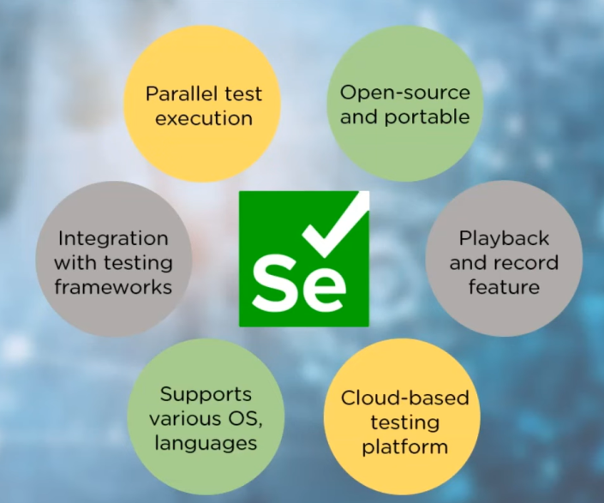

**Core Components of Selenium**

1. **Selenium WebDriver**: The main tool for controlling browsers. It allows you to interact with web elements on a page (like buttons and text fields).
2. **Selenium IDE**: (integrate development environment ) A browser extension that allows you to record and replay tests. It’s simple to use but less flexible.
3. **Selenium Grid**: Used for running tests on multiple machines or browsers at the same time, which speeds up testing.

**How to Develop a Selenium Test Script for User Login**

To develop a simple Selenium test script in Java for verifying a user login page:

1. **Set Up the Environment**:

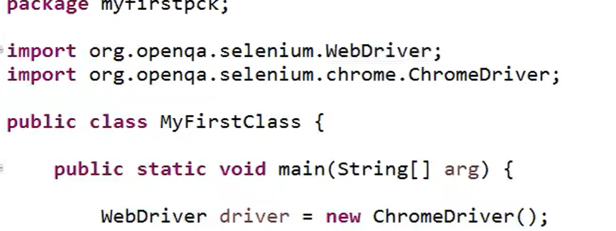

* + Download and add Selenium WebDriver to your project (using Maven or downloading the JAR files).
  + Set up the correct WebDriver for the browser you are testing (like ChromeDriver for Chrome).

1. **Create the Test Script**:
   * Open the browser.
   * Navigate to the login page of your application.
   * Enter valid username and password.
   * Click the login button.
   * Verify that the user is successfully logged in (e.g., by checking if a specific element appears on the page).

**Example Steps for a Selenium Test Script:**

* Open the browser (Chrome, for example).
* Find the username and password input fields and enter valid credentials.
* Click the "Login" button.
* Check if the user is redirected to the correct page (like a dashboard).

**Benefits of Using Selenium:**

* Automates repetitive testing tasks.
* Helps test across multiple browsers without changing the script.
* Saves time in the long run by reducing manual testing.

**Q5)Explain the concept of mocking in unit testing. Describe how Mockito facilitates mocking objects in Java unit tests, and provide a simple example.** (Covers Mockito's role in unit testing.)

**What is Mocking in Unit Testing?**

**Mocking** is a technique used in unit testing where you replace real objects with "mock" objects that simulate the behavior of real ones. The goal is to isolate the unit under test and control the environment to ensure that the unit is being tested independently. Instead of using real services, databases, or APIs, you use mocks to simulate their behavior, making the test faster and more predictable.

Mocking is particularly useful when the unit depends on other objects (like databases, APIs, or external services), but you want to test it in isolation, without calling real services or relying on external systems.

**How Mockito Facilitates Mocking in Java Unit Tests**

**Mockito** is a popular framework in Java that helps you create mock objects for unit testing. It allows you to mock classes and define the behavior of methods on those mock objects. This makes it easy to test your code in isolation without relying on real implementations.

**Key Features of Mockito:**

1. **Mocking objects**: Create mock versions of classes or interfaces.
2. **Stubbing methods**: Define what a mock object should return when specific methods are called.
3. **Verifying behavior**: Check if certain methods were called on the mock object during the test.

**How to Use Mockito in Unit Testing**

1. **Add Mockito to Your Project**:
   * If you're using Maven, you can add this dependency in your pom.xml to include Mockito:

<dependency>

<groupId>org.mockito</groupId>

<artifactId>mockito-core</artifactId>

<version>4.0.0</version>

<scope>test</scope>

</dependency>

1. **Mock an Object**:
   * You create a mock object of the class you want to test, and you define the behavior of its methods.
2. **Write the Unit Test**:
   * Call the methods on the mock object and test your unit as usual.

**Simple Example Using Mockito**

Let’s say you have a class UserService that depends on a UserRepository to fetch user data from a database. Instead of hitting a real database, you can mock the UserRepository to simulate the data fetching behavior.

**Code Example:**

1. **The Classes to Be Tested**:

java

CopyEdit

// UserRepository: A class to fetch user data from a database

public class UserRepository {

public String getUserById(int id) {

// Imagine this method talks to a real database

return "Real User";

}

}

// UserService: A class that uses UserRepository to get user info

public class UserService {

private UserRepository userRepository;

public UserService(UserRepository userRepository) {

this.userRepository = userRepository;

}

public String getUserInfo(int id) {

return userRepository.getUserById(id);

}

}

1. **The Test Using Mockito**:

import static org.mockito.Mockito.*;

import org.junit.jupiter.api.Test;

import static org.junit.jupiter.api.Assertions.*;

public class UserServiceTest {

@Test

public void testGetUserInfo() {

// Create a mock of UserRepository

UserRepository mockRepo = mock(UserRepository.class);

// Define the behavior of the mock: return "Mock User" when getUserById is called

when(mockRepo.getUserById(1)).thenReturn("Mock User");

// Create an instance of UserService with the mock repository

UserService userService = new UserService(mockRepo);

// Call the method to be tested

String result = userService.getUserInfo(1);

// Verify the result

assertEquals("Mock User", result);

// Verify if the method getUserById was called once

verify(mockRepo).getUserById(1);

}

}

**Explanation of the Example:**

1. **Mocking the UserRepository**:
   * UserRepository mockRepo = mock(UserRepository.class); creates a mock object of UserRepository. This mock object doesn't connect to a real database.
2. **Stubbing the Mock Behavior**:
   * when(mockRepo.getUserById(1)).thenReturn("Mock User"); defines the behavior for the mocked method. When getUserById(1) is called on mockRepo, it returns "Mock User" instead of querying a real database.
3. **Testing the Service**:
   * userService.getUserInfo(1); calls the method under test using the mocked repository.
4. **Assertions and Verifications**:
   * assertEquals("Mock User", result); verifies that the service returns the expected result.
   * verify(mockRepo).getUserById(1); ensures that the getUserById(1) method was indeed called during the test.

**Benefits of Using Mockito for Mocking:**

1. **Isolation**:
   * By mocking dependencies, you isolate the unit you're testing, which allows you to focus on testing just that unit.
2. **Control**:
   * You have full control over the behavior of mock objects. You can define exactly what methods should return, which is useful for testing different scenarios.
3. **Faster Tests**:
   * Mocking helps speed up tests since you avoid calling real services or databases.
4. **Easy Setup**:
   * Mockito is easy to set up and works with any Java project that uses JUnit for testing.

**Q6)Explain the concept of the pom.xml file in Maven. Describe the key elements within the pom.xml file and their purpose.** (Focuses on the core configuration file in Maven.)

**What is the pom.xml File in Maven?**

The pom.xml (Project Object Model) file is the core configuration file in a **Maven** project. It is an **XML** file that contains information about the project, such as its dependencies, build configuration, plugins, and more. Maven uses this file to manage the build lifecycle, dependencies, and project settings.

When you run Maven commands (like mvn clean install), Maven reads the pom.xml file to determine how to compile, test, and package the project.

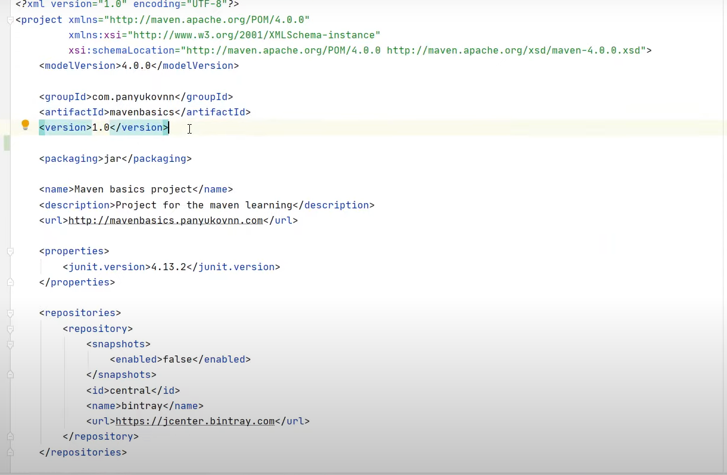

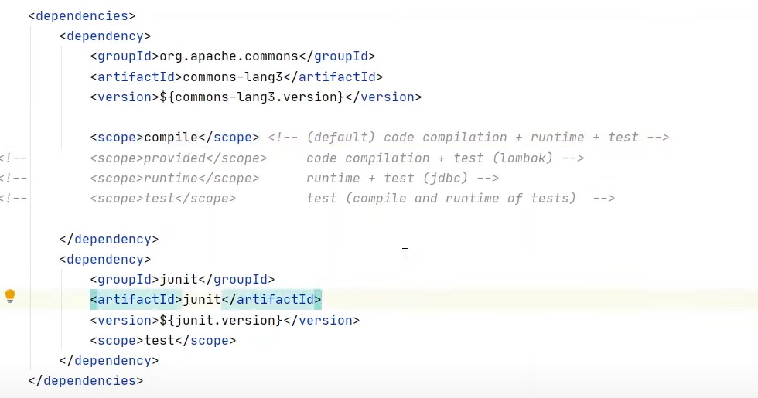

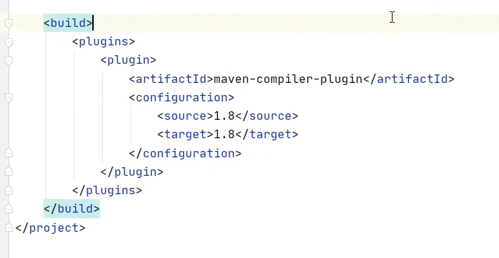

**Key Elements of the pom.xml File and Their Purpose**

Here are the most important elements found in a typical pom.xml file:

**1. Project Coordinates**

These elements define the **basic identity** of the project.

* **<groupId>**: Specifies the group or organization that owns the project. Typically, this is the reverse domain name (e.g., com.example).
* **<artifactId>**: Specifies the name of the project or artifact (e.g., my-app).
* **<version>**: Defines the version of the project (e.g., 1.0.0).
* **<packaging>**: Specifies the type of artifact, such as jar, war, pom, etc. If omitted, it defaults to jar.

<groupId>com.example</groupId>

<artifactId>my-app</artifactId>

<version>1.0.0</version>

<packaging>jar</packaging>

**2. Dependencies**

This section lists all the external libraries (JAR files) that the project depends on. Maven will automatically download and manage these dependencies from the Maven Central Repository or other specified repositories.

Example:

<dependencies>

<dependency>

<groupId>org.junit</groupId>

<artifactId>junit</artifactId>

<version>4.13.2</version>

<scope>test</scope>

</dependency>

</dependencies>

* **<groupId>**, **<artifactId>**, and **<version>**: Identifies the library.
* **<scope>**: Defines the scope of the dependency (e.g., test, compile).

**3. Build**

The <build> element defines the configuration related to the build process. It includes settings for plugins, the source directory, final artifact name, and more.

* **<plugins>**: Defines Maven plugins to extend its functionality (e.g., compiling code, creating a JAR, etc.).

Example:

<build>

<plugins>

<plugin>

<groupId>org.apache.maven.plugins</groupId>

<artifactId>maven-compiler-plugin</artifactId>

<version>3.8.1</version>

<configuration>

<source>1.8</source>

<target>1.8</target>

</configuration>

</plugin>

</plugins>

</build>

**4. Repositories**

The <repositories> section defines the external repositories (other than Maven Central) from which Maven should download dependencies.

Example:

<repositories>

<repository>

<id>example-repo</id>

<url>https://repo.example.com/maven2</url>

</repository>

</repositories>

**5. Properties**

The <properties> section allows you to define custom values for various properties that can be referenced throughout the pom.xml file. For example, the Java version or the version of a plugin.

Example:

<properties>

<java.version>1.8</java.version>

</properties>

**6. Dependencies Management**

The <dependencyManagement> section allows you to centralize the management of versions for dependencies across the entire project. You can define versions here, and then reference them in individual modules or child projects.

Example:

<dependencyManagement>

<dependencies>

<dependency>

<groupId>org.springframework</groupId>

<artifactId>spring-core</artifactId>

<version>5.3.8</version>

</dependency>

</dependencies>

</dependencyManagement>

**Summary of Key Elements**

|  |  |
| --- | --- |
| Element | Purpose |
| <groupId> | Defines the group or organization of the project. |
| <artifactId> | The unique name of the project artifact. |
| <version> | The version of the project. |
| <packaging> | Type of artifact (e.g., JAR, WAR). |
| <dependencies> | Lists external libraries the project depends on. |
| <build> | Defines build settings like plugins. |
| <repositories> | Specifies external repositories for dependencies. |
| <properties> | Defines reusable properties, like Java version. |
| <dependencyManagement> | Centralizes dependency version management. |
| <parent> | Inherits settings from a parent project or POM. |
| <profiles> | Defines different configurations for different environments. |

Top of Form

Bottom of Form

**Compare and contrast Maven with other build tools like Ant and Gradle, highlighting their respective strengths and weaknesses.** (Covers the broader build tool landscape.)

**Comparison of Maven, Ant, and Gradle**

In Java development, **Maven**, **Ant**, and **Gradle** are three widely used **build automation tools**. They help developers automate tasks like compiling code, running tests, and packaging applications. Each of these tools has its own strengths and weaknesses, and choosing the right one depends on the project’s needs, size, and complexity.

Let's break down each tool:

**1. Apache Maven**

**Overview**:  
Maven is a powerful, **opinionated** build automation tool. It follows a convention-over-configuration approach, meaning it comes with predefined structures and practices that help developers set up their projects easily.

**Strengths:**

* **Convention over Configuration**: Maven encourages a standard directory structure and lifecycle, making it easy to set up and use for new projects.
* **Dependency Management**: One of Maven’s greatest features is its **automatic dependency management**. It downloads dependencies from central repositories, ensuring that the correct versions of libraries are used.
* **Plugin Ecosystem**: Maven has a large ecosystem of plugins that can be easily integrated into the build lifecycle (e.g., for compiling, testing, and packaging).
* **Standardized Project Structure**: With Maven, all projects follow a standard structure, which makes it easier for new developers to understand existing projects.

**Weaknesses:**

* **Less Flexibility**: The convention-over-configuration approach can be limiting for complex projects that don't fit well into Maven's structure.
* **XML Configuration**: Maven’s configuration is defined in an XML file (pom.xml), which can be verbose and hard to maintain for complex projects.
* **Slow Builds**: Maven's builds can be slower than Ant or Gradle, especially for large projects, due to its strict lifecycle and dependency resolution process.

**2. Apache Ant**

**Overview**:  
Ant is one of the oldest Java build tools. It is **imperative**, meaning it gives the developer full control over the build process by allowing manual configuration of each task. Unlike Maven, Ant doesn't have predefined conventions.

**Strengths:**

* **Flexibility**: Ant allows you to define custom tasks and control the entire build process. It's perfect for projects that need a high degree of customization.
* **XML Configuration**: While this can be seen as a weakness, some developers prefer the ability to define exactly how the build process should unfold through Ant’s build.xml configuration.
* **Mature Ecosystem**: Ant has been around for a long time, so there’s a well-established ecosystem of plugins and tools available.
* **Faster Builds**: Ant can often produce faster builds since it’s more lightweight and doesn’t have the overhead of managing dependencies like Maven.

**Weaknesses:**

* **No Dependency Management**: Ant does not have built-in support for dependency management, which means developers need to manually download and include libraries, making the process prone to errors.
* **No Convention**: Unlike Maven, Ant doesn't enforce any specific structure for your project, which can lead to inconsistent project setups across teams.
* **Manual Build Process**: Ant requires developers to manually define each step of the build, making it harder to set up and maintain for complex projects compared to Maven or Gradle.

**3. Gradle**

**Overview**:  
Gradle is a modern build tool that aims to combine the best features of both **Maven** and **Ant**. It uses a **Groovy-based DSL** (Domain Specific Language) to define the build process. Gradle is highly **flexible** and **fast**, and it has gained significant popularity in recent years.

**Strengths:**

* **Flexible and Declarative**: Gradle combines the best of both worlds — it’s **declarative** like Maven but allows for a much higher level of customization, like Ant.
* **Incremental Builds**: Gradle supports **incremental builds**, meaning it only rebuilds parts of the project that have changed. This leads to faster builds, especially for large projects.
* **Built-in Dependency Management**: Like Maven, Gradle has built-in support for dependency management. It works with Maven and Ivy repositories.
* **Groovy DSL**: Gradle uses Groovy for scripting, which is more concise and expressive than XML, making it easier to write and maintain build scripts.
* **Performance**: Gradle is often faster than Maven and Ant due to features like parallel execution, caching, and incremental builds.
* **Multi-project Builds**: Gradle is excellent for managing complex multi-module or multi-project builds.

**Weaknesses:**

* **Steeper Learning Curve**: Due to its flexibility and Groovy-based DSL, Gradle can be more difficult for beginners compared to Maven and Ant.
* **Newer Tool**: While gaining popularity, Gradle is still not as widely adopted as Maven in some industries, and finding resources or documentation can sometimes be harder.

**Comparison Summary**

|  |  |  |  |
| --- | --- | --- | --- |
| Feature | Maven | Ant | Gradle |
| Approach | Convention over configuration | Imperative, manual configuration | Flexible, declarative with DSL |
| Dependency Management | Built-in, automatic dependency resolution | None, requires manual management | Built-in, supports Maven/Ivy repos |
| Configuration File | XML (pom.xml) | XML (build.xml) | Groovy DSL (build.gradle) |
| Ease of Use | Easy for simple projects | Flexible but more complex setup | Moderate learning curve |
| Flexibility | Less flexible, predefined setup | Very flexible, but manual | Very flexible, more declarative |
| Build Speed | Slower due to lifecycle overhead | Faster for smaller projects | Faster, with incremental builds |
| Plugin Ecosystem | Large, with many plugins | Mature, but fewer out-of-the-box plugins | Growing, but more modern |
| Multi-project Builds | Supported, but more complex | Not ideal for large projects | Excellent support for multi-projects |
| Custom Tasks | Limited customization | Full control over tasks | Supports custom tasks and extensions |

**Which Tool to Choose?**

* **Use Maven if**:
  + You need a standardized, opinionated tool with automatic dependency management and predefined conventions.
  + You prefer a tool with a large ecosystem and community support.
  + Your project is relatively simple and you don't need a high degree of customization.
* **Use Ant if**:
  + You need maximum flexibility and control over your build process.
  + You have a legacy project that already uses Ant or you need to build non-Java projects.
  + You’re working on a smaller project or something that doesn’t require complex dependency management.
* **Use Gradle if**:
  + You need fast builds with incremental processing and parallel execution.
  + You need a modern, flexible tool that can easily scale for complex, multi-module projects.
  + You want to use a more expressive build script language (Groovy) and have the flexibility to fine-tune your build process.

**Conclusion**

Each of these tools — Maven, Ant, and Gradle — has its own strengths and weaknesses. Maven is best for projects that require standardized setups and dependency management. Ant is ideal for those who need maximum flexibility and control, especially in smaller projects or legacy systems. Gradle is the best choice for modern, large-scale projects requiring fast, flexible builds with incremental support and a Groovy-based DSL. The right tool for your project depends on the specific needs of your build process and the complexity of your project.

Top of Form

Bottom of Form

**UNIT 4**

**Q1)What is a Jenkins pipeline? Describe its structure and explain how it helps in automating the software delivery process.**

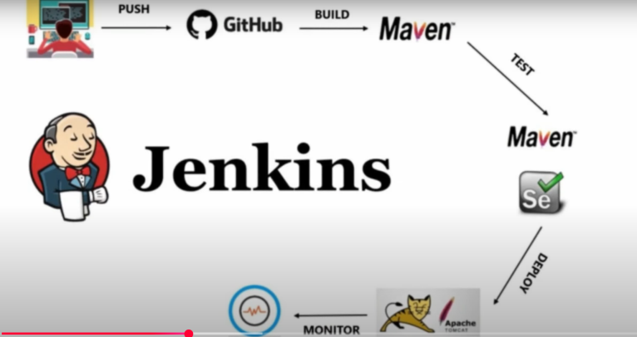

**Jenkins Pipeline: Simplified Explanation**

A **Jenkins pipeline** is a system that helps automate the process of building, testing, and deploying software. It ensures that software is developed efficiently without manual work at every step.

**What is a Jenkins Pipeline?**

Jenkins pipeline is like a **step-by-step roadmap** that guides a software project from start to finish. It makes sure that everything is done **correctly, automatically, and repeatedly**, reducing human errors and saving time.

**Why Use a Jenkins Pipeline?**

Before pipelines, developers had to manually compile code, test it, and deploy it. This was time-consuming and prone to mistakes. Jenkins automates these tasks so software can move smoothly through different stages without manual intervention.

**Structure of a Jenkins Pipeline**

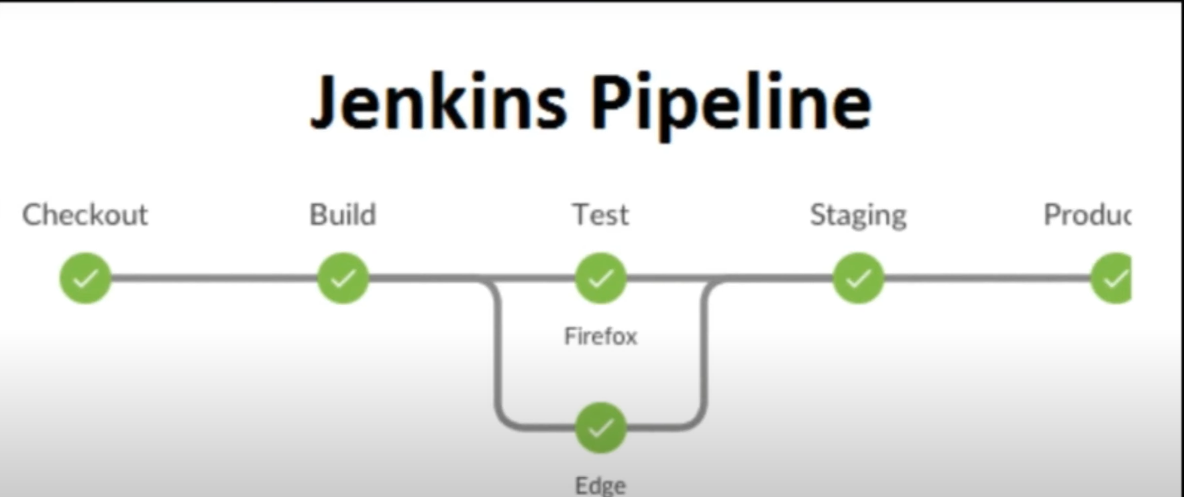

1. **Build Stage**
   * This is where the code is compiled and converted into a working application.
   * If there are missing files or errors, Jenkins detects them early.
2. **Test Stage**
   * The application is tested to check if everything is working correctly.
   * Automated tests find bugs and ensure reliability.
3. **Deploy Stage**
   * Once tested, the application is sent to a staging or production environment.
   * It can be released for users or further improvements.

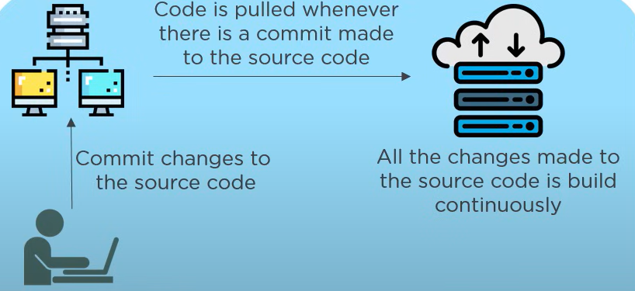

* **Types of Pipelines in Jenkins**

**Declarative Pipeline**

Uses simple, structured syntax.

Written in a Jenkinsfile, making automation easy.

**Scripted Pipeline**

More flexible but requires complex scripting.

Used for advanced configurations.

**How Jenkins Pipeline Helps Automation**

1. **Saves Time** – Developers don’t have to manually build, test, or deploy software.
2. **Ensures Consistency** – Every code change goes through the same automated steps.
3. **Reduces Errors** – Automated testing catches bugs before release.
4. **Enables Continuous Integration (CI)** – Developers merge their code frequently, and Jenkins tests it automatically.
5. **Supports Continuous Delivery (CD)** – Software is always ready for deployment.

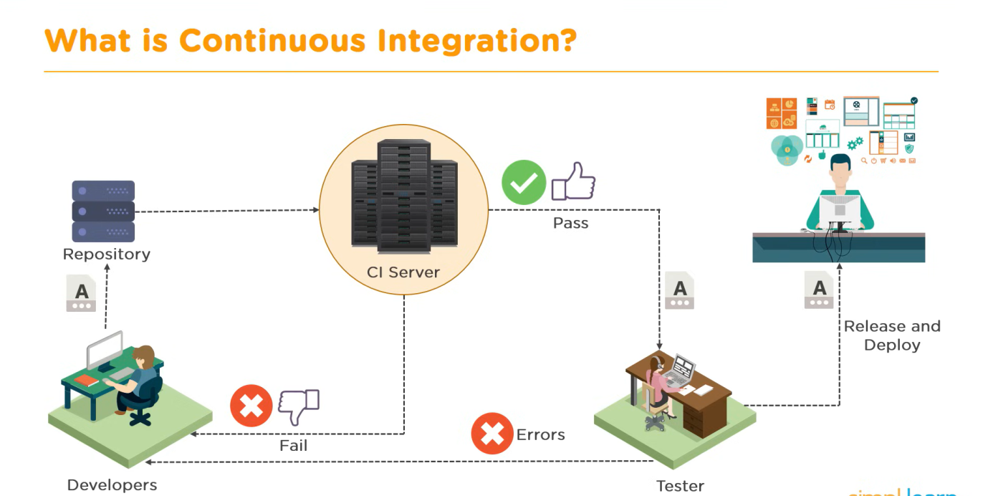

**Conclusion**

Jenkins pipeline simplifies software development by **automating repetitive tasks** like building, testing, and deployment. It ensures faster and more reliable software delivery while reducing human effort.

**Q2)Explain the difference between Continuous Delivery and Continuous Deployment. Discuss the key benefits of implementing Continuous Delivery in a DevOps environment.**

**Continuous Delivery (CD)** and **Continuous Deployment (CD)** are both essential practices in DevOps that ensure smooth and automated software releases. While they share common principles, they differ in how frequently changes reach production.

**Key Differences Between Continuous Delivery & Continuous Deployment**

|  |  |  |
| --- | --- | --- |
| Feature | Continuous Delivery | Continuous Deployment |
| Deployment Process | Software is **always ready** to be deployed but requires manual approval | Software updates are **automatically released** to production |
| Manual Intervention | **Yes** – A human decides when to deploy | **No** – Every validated change is automatically deployed |
| Risk & Control | Provides **control** over releases, allowing testing & approvals before deployment | High-speed releases but **less control**, requiring strong automated testing |
| Use Case | Suitable for **regulated industries** that require manual review | Ideal for **fast-moving tech teams** that deploy updates frequently |

**Key Benefits of Continuous Delivery in DevOps**

**Faster Release Cycles** – Reduces the time between development and deployment, ensuring frequent updates.  
**Improved Software Quality** – Automated testing and CI/CD pipelines detect issues early.  
**Reduced Deployment Risks** – Allows gradual, low-risk releases instead of sudden major updates.

**Better Collaboration** – Enables seamless teamwork between developers, testers, and operations teams.  
**Flexibility in Deployment** – Teams can choose when and how to release updates, ensuring stability.

Continuous Delivery ensures **smooth, reliable, and efficient** software releases, making it a crucial part of modern DevOps environments.

**Q3)Describe the role of Nexus in dependency management and how it integrates with SonarQube. Outline the steps involved in setting up Nexus and SonarQube integration.**

**Role of Nexus in Dependency Management**

Nexus is a **repository manager** that stores and manages dependencies used in software development. It helps teams maintain versions of **libraries, artifacts, and dependencies**, ensuring consistent and reproducible builds.

**Why Nexus is Important?**

* Acts as a central storage for libraries, preventing repeated downloads from external sources.
* Improves performance by caching dependencies locally.
* Ensures **secure & controlled access** to dependencies within teams.

**How Nexus Integrates with SonarQube?**

SonarQube is a tool that **analyzes code quality**, checking for bugs, vulnerabilities, and best practices. Integration with Nexus ensures that dependencies used in a project **meet quality standards** before deployment.

**Benefits of Integration:**

* Ensures only verified dependencies are used.
* Helps maintain security by scanning libraries for vulnerabilities.
* Automates the process of code validation.

**Steps to Set Up Nexus & SonarQube Integration**

**Install Nexus Repository Manager** and configure it as the central dependency storage.  
**Install SonarQube** and set it up for code scanning & analysis.  
**Configure SonarQube to scan dependencies stored in Nexus** using a plugin or manual verification.  
**Automate the process with CI/CD pipelines** to ensure only clean code and verified dependencies are deployed.

By integrating Nexus with SonarQube, teams maintain **secure, high-quality software builds** while automating dependency validation.

**Q4)What is Ansible, and how does it contribute to automation in IT operations and software development? Evaluate the impact of adopting Ansible on collaboration within teams.**

**What is Ansible?**

Ansible is an **automation tool** that helps manage IT infrastructure, software deployment, and configuration management. It uses **simple YAML-based scripts** called **playbooks** to automate tasks across multiple servers.

**Key Features of Ansible:**

* **Agentless Architecture** – No need to install additional software on target machines.
* **Declarative Language** – Uses YAML, making automation easy to understand and maintain.
* **Scalability** – Can automate tasks across hundreds of systems efficiently.

**How Ansible Helps in IT Operations & Software Development?**

* **Configuration Management** – Automates software setup and updates across servers.
* **Provisioning & Deployment** – Sets up new environments in **cloud or on-premises**.
* **Security & Compliance** – Ensures systems follow security best practices automatically.

**Impact of Adopting Ansible on Collaboration**

**Improves Developer & Ops Communication** – Both teams use Ansible playbooks for consistent automation.

**Reduces Manual Work** – Automated deployments ensure repeatability without errors.

**Boosts Efficiency** – Teams focus on **innovation** instead of manual system setup.  
**Enhances Standardization** – Ensures all infrastructure follows the same rules, reducing inconsistencies.

Ansible streamlines **IT processes, speeds up deployments**, and **strengthens collaboration**, making it a vital tool in modern DevOps.

**Q5) Describe the key components of a Configuration Management system and explain how they contribute to the overall software development process.**

**Configuration Management (CM)** is a process used in software development to make sure that systems are set up correctly, remain stable, and can easily be updated when needed. It helps teams manage changes to software and systems without causing problems. Let’s look at its key components and how they help.

**key Components of Configuration Management:**

1. **Version Control:**
   * This keeps track of all changes made to software code and system settings.
   * Tools like **Git** are commonly used.
   * It allows developers to go back to an earlier version if something goes wrong.
   * This helps avoid mistakes from unexpected changes and keeps the system stable.
2. **Automation and Scripting:**
   * Tools like **Ansible**, **Puppet**, and **Chef** are used to automatically set up and configure systems.
   * Instead of doing things manually, scripts are written to install software, update systems, or configure settings.
   * This saves time, reduces errors, and makes the deployment process much faster and more consistent.
3. **Monitoring and Auditing:**
   * This tracks how systems are performing and checks if everything is working as expected.
   * It also watches for security issues or changes made to the system.
   * Monitoring tools help detect problems early, so they can be fixed quickly before causing bigger issues.
   * Auditing also helps maintain **compliance** with rules or security standards.
4. **Change Management:**
   * This controls how updates and changes are made to the system.
   * It ensures that every change is tested and approved before it is applied.
   * This helps prevent conflicts between different versions or unexpected behavior in the system.
   * It ensures smooth upgrades and transitions.

**How Configuration Management Helps in Software Development:**

* **Consistency Across Environments:**  
  It ensures that development, testing, and production environments are all set up the same way. This avoids the problem of something working in one environment but failing in another.
* **Reliability:**  
  Systems behave in predictable ways, reducing crashes and downtime. This improves the reliability of applications.
* **Security:**  
  By automating updates and patches, it helps close security holes quickly, protecting the system from threats.
* **Faster and Smoother Deployments:**  
  With automation and version control, teams can set up or roll back infrastructure quickly, making deployments more efficient.

**Q6)How does Jenkins support integration with version control systems like Git? Explain how Jenkins facilitates continuous integration (CI) through its pipeline feature.** (Focuses on Jenkins' integration capabilities and CI.)

**Scenario: Developing a Web Application**

Imagine a team of developers working on a web application. They use Git for version control to manage their codebase, and they want to implement Continuous Integration using Jenkins to automate the build, test, and potentially deployment processes whenever code changes are made.

**1. Version Control with Git:**

* The developers store their application code (HTML, CSS, JavaScript, backend code, configuration files, etc.) in a Git repository hosted on a platform like GitHub, GitLab, or Bit bucket.
* Each developer works on their features or bug fixes in separate branches.
* When a developer completes their work, they commit their changes and push them to the remote Git repository.
* To integrate their changes with the main codebase, they create a "Pull Request" (or "Merge Request") to merge their branch into the main branch (e.g., main or develop).

**2. Jenkins Integration with Git:**

* **Setting up the Jenkins Job:** A Jenkins administrator or a developer with the necessary permissions creates a new Jenkins "Pipeline" job.
* **Configuring Git Repository:** In the Pipeline configuration, they specify the URL of the Git repository containing the web application's code.
* **Specifying Credentials (if needed):** If the Git repository is private, they configure Jenkins with the necessary credentials (e.g., username/password or SSH keys) to access the repository.
* **Defining the Branch to Build:** They specify the branch that Jenkins should monitor and build (e.g., the main branch, or potentially trigger builds on Pull Requests).

DevOps and CI/CD Pipelines:

DevOps: A combination of development and operations practices, aiming for frequent releases, improved team collaboration, better management, and faster issue resolution.

CI/CD Pipeline: The backbone of DevOps, automating the build, test, and deployment process. It's a series of interconnected events executed sequentially.

Continuous Integration (CI): Automates code integration into a shared repository, verifying code and detecting bugs early.

Continuous Delivery (CD): Automates the process of making changes to the code before deployment, ensuring a smooth delivery to the customer.

CI/CD together: Automates build and deployment, making teams more agile, productive, and confident.

II. Jenkins and CI/CD Pipeline Implementation:

Jenkins: An open-source orchestration tool ideal for building CI/CD pipelines due to its flexibility, open-source nature, plugin support, and user-friendly interface. It supports various programming languages.

Pipeline Steps (Generic): Requires Java JDK, understanding of Linux commands, Jenkins installation, creation of a new pipeline job, configuration of the pipeline script (either directly inputted or fetched from a source code management tool like Git), execution of the pipeline job, and monitoring the build process.

Jenkins Pipeline Job Creation: Involves selecting the pipeline job type, providing a name, specifying the pipeline script location (e.g., GitHub repository), configuring credentials (if needed for private repositories), and initiating the build.

Pipeline Execution and Monitoring: After initiating the build, you can monitor the progress through the console output, viewing logs for each stage.

III. Demo and Conclusion:

demo showcases creating a simple pipeline in Jenkins, demonstrating the process of setting up a pipeline job, linking it to a Git repository containing a Jenkinsfile, and executing the pipeline. The demo shows the stages of the pipeline (checkout, build, test, etc.) and the final success/failure status.

The conclusion summarizes the process of building and automating CI/CD pipelines using Jenkins

The source also mentions specific technical details like using java -jar jenkins.war to run Jenkins, accessing it via localhost:8080, and using the checkout scm step in the Jenkinsfile. However, these are embedded within the broader points outlined above.

**UNIT 5**

**Q1)Difference Between a Docker Image and a Docker Container & How to Create and Manage Them**

**Docker Image vs. Docker Container**

A **Docker Image** is a **blueprint** for creating containers. It consists of all necessary components, such as software, dependencies, and configurations, required to run an application. Since an image is **static**, it does not execute on its own but serves as a **template** for building containers.

A **Docker Container**, on the other hand, is a **running instance** of a Docker Image. It provides an **isolated environment** where applications can run reliably, ensuring portability and consistency across different computing environments. Containers encapsulate the application along with its dependencies, making it easy to deploy across different infrastructures without worrying about compatibility issues.

**How to Create a Docker Image**

1. **Write a Dockerfile** – A **Dockerfile** is a script containing instructions to create a Docker Image. It specifies the **base image**, application dependencies, environment settings, and startup commands.
   * Example Dockerfile:
2. FROM ubuntu:latest
3. RUN apt-get update && apt-get install -y nginx
4. COPY index.html /var/www/html/
5. CMD ["nginx", "-g", "daemon off;"]

This Dockerfile uses **Ubuntu** as the base image, installs **Nginx**, copies an HTML file, and starts the Nginx server.

1. **Build the Image** – Use the docker build command to create an image from the Dockerfile.
2. docker build -t my_webserver .

The -t flag assigns a name to the image (my_webserver), and the . indicates that the Dockerfile is in the current directory.

1. **Store the Image** – Once created, the image can be stored in **Docker Hub** (a public repository) or a **private registry** to share and distribute it.
   * Push the image to Docker Hub:
2. docker tag my_webserver myrepo/my_webserver:v1
3. docker push myrepo/my_webserver:v1

**How to Manage Docker Containers**

Containers are **instances of images** and can be created, monitored, and removed as needed.

**Starting and Stopping Containers**

* **Start a container** using docker run. If the image doesn’t exist locally, Docker pulls it automatically.
* docker run -d --name my_container -p 8080:80 my_webserver

The -d flag runs the container in the background, --name assigns a name (my_container), and -p 8080:80 maps port **8080** of the host to port **80** of the container.

* **Stop a container**
* docker stop my_container
* **Restart a container**
* docker restart my_container

**Monitoring and Managing Containers**

* **Check running containers**
* docker ps
* **View logs** of a container for debugging
* docker logs my_container
* **Check resource usage (CPU, memory, network)**
* docker stats my_container

**Removing Containers**

* **Stop and remove a container**
* docker rm my_container
* **Remove all stopped containers**
* docker container prune

**Why Docker Images and Containers Matter?**

Using **Docker Images and Containers**, developers can:  
Ensure **consistency** across development, testing, and production environments.  
Improve **scalability** and deployment efficiency.  
Enhance **security** by isolating applications from the host system.  
Simplify **updates**, making rolling out new versions seamless.

**Q2. What is Docker? Why Use Docker? Key Docker Tools & Architecture**

### ****Docker****

Docker is a technology that packages applications into containers so they can run consistently on different machines.

### ****Why Use Docker?****

• It ensures applications run the same way on any system.  
• Makes applications lightweight and fast.  
• Speeds up development by reducing dependency conflicts.

### ****Key Docker Tools****

• **Dockerfile** – Defines the image setup.  
• **Docker Hub** – Stores and shares images.  
• **Docker Compose** – Runs multiple containers at once.

### ****Docker Architecture****

### Understanding Docker Architecture: A Comprehensive Guide | by Ravi Patel | Medium

Docker follows a client-server model:  
• **Docker CLI** – Lets users send commands.  
• **Docker Daemon** – Runs containers.  
• **Docker Registry** – Stores images.

### ****Q3)Introduction to Kubernetes & Its Objects****

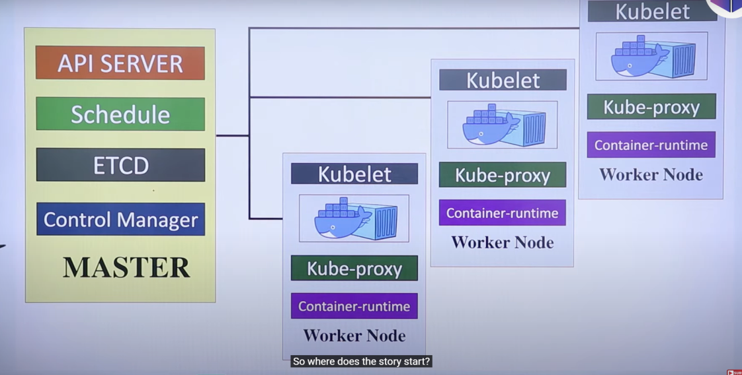

**Kubernetes: An Orchestration Tool for Containerized Applications**

1. **Introduction to Kubernetes:**
   * Kubernetes is an orchestration tool used to manage containerized applications at scale.
   * It is designed to automate deployment, scaling, and operation of application containers across clusters of hosts.
2. **Pre-requisite Knowledge:**
   * Understanding Docker containers is essential before learning Kubernetes.
3. **Problem Solved by Kubernetes:**
   * Manages thousands of containers efficiently.
   * Addresses issues like:
     + Auto-scaling of applications.
     + Load balancing between containers.
     + Handling node or container failures.
     + Continuous deployment and monitoring.
4. **Kubernetes as an Orchestration Tool:**
   * Works like a conductor in an orchestra, ensuring all components (containers) work together harmoniously.
5. **Kubernetes Architecture:**
   * **Master Node:** Central control point of the cluster.
     + Coordinates the cluster and manages the system.
   * **Worker Nodes:** Run the actual containerized applications.
     + Perform the tasks assigned by the master node.
6. **Hotel Analogy to Explain Workflow:**
   * **Client Request:** Like a hotel guest requesting a room (application deployment).
   * **API Server:** Acts as hotel reception; receives requests and communicates with other components.
   * **ETCD:** Acts as a reservation system; stores configuration and cluster state in a key-value format.
   * **Scheduler:** Like a hotel manager; assigns pods (rooms) to applications based on available resources.
   * **Pod:** A unit of deployment in Kubernetes; contains one or more containers.
   * **Kubelet:** Like room service; ensures the pod is set up and running as expected on the worker node.
   * **Kube-proxy:** Manages networking and load balancing; ensures communication between pods and services.
   * **Controller Manager:** Oversees cluster state; handles replication, failures, and maintains the desired state.
7. **Key Roles of Kubernetes Components:**
   * **API Server:** Entry point for all administrative commands.
   * **ETCD:** Stores all cluster data.
   * **Scheduler:** Assigns workloads to worker nodes.
   * **Kubelet:** Runs on worker nodes and manages pods.
   * **Kube-proxy:** Manages network communication and load balancing.
   * **Controller Manager:** Ensures the system runs as expected (e.g., pod restarts, scaling).
8. **Conclusion:**
   * Kubernetes ensures high availability, scalability, and efficient management of containerized applications.
   * The hotel analogy helps in understanding how each component plays a vital role in the orchestration process.

**Q4. Deploying & Scaling Applications Using Kubernetes & Breaking a Monolithic Application**

### ****How to Deploy Applications****

Deploying applications efficiently requires a well-structured approach to ensure stability, scalability, and seamless communication within the infrastructure.

**Defining Application Settings**  
• Before deployment, application settings must be configured, including environment variables, resource limits, and access permissions.  
• Define dependencies and required libraries to ensure smooth execution within the containerized environment.  
• Establish configuration files or secrets management to securely store sensitive information, such as database credentials and API keys.

**Deploying Containers into Kubernetes**  
• Containers are packaged with the application code and its dependencies, ensuring consistent execution across different environments.  
• Kubernetes manages container orchestration, allowing efficient deployment and scaling.  
• A Kubernetes Deployment or StatefulSet is used to define how containers should run, update, and maintain high availability.  
• The kubectl apply -f deployment.yaml command applies the configuration, creating and managing the required containers.

**Setting Up Networking for Communication**  
• Kubernetes Services enable communication between different parts of an application by exposing containers internally or externally.  
• Cluster networking ensures that microservices, databases, and other infrastructure components can interact securely.  
• A Load Balancer or Ingress Controller is configured to manage incoming traffic, enabling efficient routing of requests.

**Monitoring Logs to Ensure Stability**  
• Kubernetes provides logging and monitoring tools, such as Prometheus, Grafana, and Fluentd, to track application performance and detect issues early.  
• Logs can be accessed using kubectl logs pod_name, which helps troubleshoot errors and monitor real-time data.  
• Health checks and readiness probes ensure that applications remain operational, restarting failed components when needed.

### ****How to Scale Applications****

Scaling applications dynamically is essential for handling varying workloads and optimizing resource utilization.

**Using Auto-Scaling Features**  
• Kubernetes Horizontal Pod Autoscaler (HPA) automatically adjusts the number of running pods based on CPU usage and other metrics.  
• Cluster Autoscaler scales nodes in response to workload demands, ensuring sufficient infrastructure support.  
• Scaling policies can be configured to trigger resource expansion or reduction, optimizing performance and cost efficiency.

### ****Breaking Down a Monolithic Application****

Modern applications benefit from being broken down into microservices to enhance scalability, resilience, and independent development.

**Converting the System into Microservices**  
• A monolithic application is divided into smaller, independent services that focus on specific functionalities, reducing complexity.  
• Each microservice has its own database, logic, and API interactions, improving modularity and flexibility.

**Containerizing Each Microservice Separately**  
• Each microservice runs in its own container to maintain isolation and avoid dependency conflicts.  
• Docker Images are created for each microservice, ensuring easy deployment and portability.  
• Kubernetes orchestrates the containers, allowing independent scaling and management.

**Using Kubernetes to Manage and Connect Microservices**  
• Kubernetes Service Discovery enables efficient communication between microservices within the cluster.  
• APIs facilitate interaction between services, ensuring seamless functionality.  
• Kubernetes facilitates rolling updates and version control, allowing modifications without affecting overall application performance.

**5. Importance of Monitoring and Logging in DevOps**

### ****1. Importance in DevOps****

* DevOps includes Continuous Integration (CI), Continuous Delivery (CD), and fast deployments.
* **Monitoring and logging help maintain system health and reliability.**
* They allow teams to:
  + **Detect problems early**
  + **React quickly**
  + **Keep systems secure and scalable**

### ****2. Detecting Errors and Performance Issues Early****

* **Monitoring** tracks key metrics like:
  + CPU usage
  + Memory usage
  + Response time
  + Error rate
* **Why it's useful:**
  + Helps catch issues like:
    - Memory leaks
    - Slow database queries
    - High server load
  + **Real-time alerts** inform the team instantly of any problems.
  + Reduces system **downtime** and improves performance.

### ****3. Improving Security by Tracking Unusual Activity****

* **Logging** records important actions, such as:
  + User logins
  + API calls
  + System changes
* **Why it matters:**
  + Helps detect **unauthorized access**, hacking attempts, or unusual behavior.
  + Acts as a **security audit trail**.
  + Helps meet **compliance requirements** and perform security investigations.

### ****4. Supporting Troubleshooting and Root Cause Analysis****

* **Logs show what happened before, during, and after a problem.**
* When combined with monitoring data, logs help:
  + **Find the root cause** of the issue (e.g., a CPU spike during a failed deployment).
  + Reduce **Mean Time to Recovery (MTTR)**.
  + Speed up **debugging and system recovery**.

**6. Implementing Monitoring in DevOps & Continuous Improvement**

### ****Monitoring in DevOps****

Monitoring is a critical component of DevOps, ensuring that systems and applications operate efficiently, securely, and reliably. It provides real-time visibility into infrastructure health, enabling teams to detect anomalies, optimize performance, and improve overall system stability.

### ****Tracking CPU, Memory, and Network Usage****

• Monitoring tools such as **Prometheus, Grafana, Datadog, and Nagios** collect and visualize essential metrics, including **CPU load, memory consumption, disk I/O, and network bandwidth usage**.  
• These metrics help DevOps teams analyze resource utilization, detect bottlenecks, and optimize server performance to ensure seamless application functionality.

### ****Detecting Errors and Sending Alerts****

• Monitoring solutions identify issues such as **application crashes, server downtime, and network failures**, triggering immediate alerts.  
• Alerts can be sent via **email, SMS, Slack, or integrated notification systems**, ensuring teams can respond proactively to prevent service disruptions.  
• Early anomaly detection helps maintain high availability and reduces the risk of prolonged outages.

### ****Optimizing Server Performance****

• Continuous tracking of system performance allows teams to **adjust resource allocations**, scale services dynamically, and improve response times.  
• Monitoring historical data and trends helps predict future resource needs, ensuring smooth operations even during peak loads.  
• Load balancing and auto-scaling mechanisms enhance efficiency by distributing workloads across multiple nodes.

### ****How Monitoring Supports Continuous Improvement****

**Real-time Feedback**  
• Monitoring delivers immediate insights into **application performance, infrastructure health, and user experience**, allowing teams to iterate quickly and implement necessary improvements.

**Failure Prediction**  
• Trend analysis and AI-driven anomaly detection help identify **patterns such as memory leaks, increasing CPU usage, or failing components** before they cause major system failures.  
• Predictive analytics empower teams to take **preemptive action**, reducing downtime and enhancing system reliability.

**Incident Response**  
• Logs and automated alerts facilitate **quick isolation and resolution** of issues, minimizing disruption.  
• Advanced monitoring strategies help **correlate system events with errors**, enabling faster debugging and reducing Mean Time to Recovery (**MTTR**).

**7. Persistent Data Storage in Docker & Best Practices**

### ****How Docker Handles Data Storage****

Docker provides multiple methods for handling data storage efficiently, ensuring that data remains persistent even when containers are stopped, removed, or recreated. Unlike traditional virtual machines, Docker containers are **ephemeral**, meaning their filesystem is destroyed when a container is deleted. To retain important application data, Docker employs **Volumes** and **Bind Mounts** as storage mechanisms.

**Volumes**  
• Volumes are managed by Docker and stored **outside** the container’s writable layer, ensuring data persistence even when containers are removed.  
• Docker stores volumes under /var/lib/docker/volumes/, keeping application data separate from container layers.  
• Volumes provide portability, as they can be **backed up**, **shared among multiple containers**, and **used with storage drivers** for cloud-based or remote storage solutions.  
• Recommended for databases, logs, and application data that must persist beyond the container lifecycle.

**Bind Mounts**  
• Bind mounts allow **direct mapping** between a directory on the host machine and a path inside the container.  
• Unlike volumes, bind mounts reference the **exact file locations** on the host system rather than using a Docker-managed storage space.  
• Bind mounts are useful when a container needs direct access to host data, such as configurations or external storage.  
• More flexible than volumes, but **not as portable**, since paths may vary across different environments.

By separating data from containers, Docker ensures that **important files, databases, and configurations persist** beyond a container’s lifecycle, making deployment more reliable and efficient.

### ****Best Practices for Managing Docker Data****

**Use Volumes Instead of Bind Mounts**  
• Volumes are preferred over bind mounts because they are **fully managed by Docker**, portable, and work with remote storage providers.  
• Volumes support **container orchestration** platforms like Kubernetes and Docker Swarm for scalable workloads.  
• Bind mounts, while useful for local development, are **less reliable** for production environments due to host system dependencies.

**Avoid Storing Data Inside Containers**  
• Any data stored directly inside a container is **lost** when the container is removed or recreated.  
• Always use **mounted volumes** for persistent storage, particularly for **databases, logs, and application settings**.  
• Applications that require data persistence should store files outside the container’s temporary filesystem.

**Implement Backups**  
• Regular backups of volumes **prevent data loss** and ensure recovery in case of failures or accidental deletions.  
• Tools like **Restic, Duplicity, and Docker Volume Backup plugins** automate data backups to cloud storage or external systems.  
• Scheduled backups can be performed using docker run --rm -v my_volume:/data busybox tar czf /backup/data.tar.gz /data.

**Secure Data**  
• Proper **access controls** prevent unauthorized modifications to mounted volumes.  
• Encryption methods ensure **data confidentiality**, particularly for sensitive application files.  
• Implement **role-based access controls (RBAC)** for containerized environments, restricting volume access to authorized services and users.

**8. Docker Networking & Communication Techniques**

### ****How Docker Handles Networking****

Docker provides multiple networking options to enable **container-to-container communication**, inter-container networking across hosts, and integration with external systems. Containers, by default, **operate in isolated environments**, but they need networking to interact with each other or external applications. Docker achieves this using different **network drivers** tailored for various scenarios.

**Bridge Network (Default)**  
• The **bridge network** is the default networking mode in Docker. It allows containers on the **same host** to communicate using **internal IP addresses**, while restricting external access unless explicitly allowed.  
• Containers on a bridge network can use **custom subnets** and port forwarding, enabling flexible connectivity between different services running on the same machine.  
• The docker network create my_bridge_network command creates a custom bridge network for better container communication control.

**Host Network**  
• The **host network** removes isolation and **shares the network stack** of the host machine, meaning containers operate directly on the host’s network.  
• This setup eliminates network translation overhead, making applications **run faster**, but comes with **security risks**, since all containers have direct access to host resources.  
• Running a container with docker run --network host my_app means it communicates on the host’s IP instead of its own.

**Overlay Network**  
• The **overlay network** is used when containers need to communicate **across multiple hosts**, making it ideal for **Docker Swarm or Kubernetes clusters**.  
• It enables containers on different physical machines to interact as if they were on the same local network, ensuring **distributed application scalability**.  
• Creating an overlay network using docker network create --driver overlay my_overlay_network helps support multi-host container communication.

**Macvlan Network**  
• The **Macvlan network driver** assigns a **MAC address** to each container, making them appear as **physical devices** on the network.  
• This is useful when containers need direct access to the host’s network **without NAT or port mapping**, ensuring **low-latency, high-performance networking**.  
• Macvlan networks are ideal for scenarios where containers need **custom IP addresses**, such as IoT applications or networking infrastructure setups.

### ****Best Practices for Docker Networking****

**Use Overlay Networks for Multi-Host Communication**  
• Overlay networks are essential in **distributed environments**, such as **Docker Swarm and Kubernetes**, where containers need to communicate **across multiple hosts**.  
• They enable **secure, scalable, and efficient networking** without requiring manual configuration for each node.

**Enable DNS-Based Discovery**  
• Docker provides an **internal DNS** to resolve **container names into IP addresses**, making **service discovery dynamic** and eliminating the need for hardcoded IPs.  
• Using docker-compose or docker service create in Swarm allows automatic **DNS resolution** among containers, simplifying communication.

**Secure Networking**  
• **Restrict open ports** by exposing only necessary ones and avoiding public access where possible.  
• **Use firewalls and network policies** to **control traffic flow** and **prevent unauthorized access** (e.g., in Kubernetes via NetworkPolicy).  
• **Enable TLS encryption** for **secure container communication**, ensuring that data transmitted between services remains **protected from interception**.  
• **Configure IP whitelisting and segmentation** to **limit traffic exposure** and protect sensitive containerized services from external threats.

**10. Dockerfile for a Node.js App & Production Considerations**

### ****Sample Dockerfile for a Node.js Application****

A **Dockerfile** is used to automate the creation of **Docker images**, ensuring consistency across different environments. Below is a structured Dockerfile for a Node.js application:

# Use official Node.js image

FROM node:18-alpine

# Set the working directory inside the container

WORKDIR /app

# Copy package files and install dependencies

COPY package*.json ./

RUN npm install --production

# Copy source code into the container

COPY . .

# Expose the application port

EXPOSE 3000

# Define the startup command

CMD ["node", "app.js"]

### ****Advantages of Using Docker in Production****

**Consistency**  
Docker provides a **standardized environment**, ensuring applications behave the same way across **development, testing, and production stages**. This eliminates compatibility issues caused by different system configurations.

**Fast Deployment**  
Since Docker images are **pre-built**, they can be deployed quickly without needing to manually install dependencies or configure environments. This significantly speeds up **deployment cycles** and minimizes downtime.

**Scalability**  
Docker works seamlessly with **orchestration tools** like **Kubernetes** and **Docker Swarm**, allowing applications to scale **dynamically** based on demand. Additional instances of containers can be spun up instantly to handle increased traffic.

**Isolation**  
Each container runs in its **own isolated environment**, preventing **dependency conflicts** between applications. This allows multiple applications to coexist on the same infrastructure without interfering with one another.

### ****Disadvantages of Using Docker in Production****

**Resource Overhead**  
While containers are lightweight compared to virtual machines, running **too many** containers can **strain system resources** such as CPU and memory, leading to performance degradation.

**Security Risks**  
Misconfigured containers, such as running them with **root privileges** or exposing unnecessary **ports**, can introduce security vulnerabilities. Ensuring **proper security policies** and restricting container access is crucial.

**Complex Networking**  
Managing **service discovery, load balancing, and network policies** can be challenging, especially in **multi-container applications** that span across multiple hosts. Proper **network configuration** is required to ensure seamless communication.

**Persistent Data Challenges**  
Docker containers are **stateless**, meaning data inside a container is lost when it is removed. To handle **persistent storage**, teams must mount **volumes** or use **external databases**, adding complexity to data management strategies.

Problem Statement:

Designing a DevOps Workflow for a Software Development Project.  New project to develop a web-based application. The project aims to enhance collaboration among team members, streamline development processes, ensure high code quality, and enable efficient deployment and operations. However, the lack of a structured DevOps workflow is hindering the project's progress and efficiency.

Design Assignment:

Your task is to design a comprehensive DevOps workflow for the development, testing, deployment, and operation of the CRM application. The workflow should address the following key aspects:

Task 1:  Flow Chart

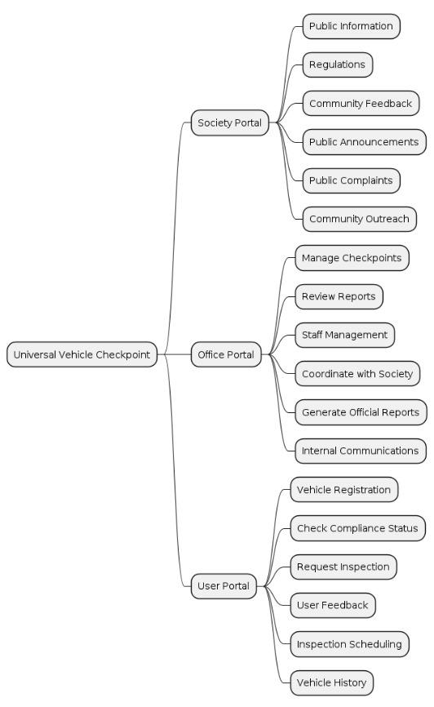

Task 2: Test The Test Cases Selenium

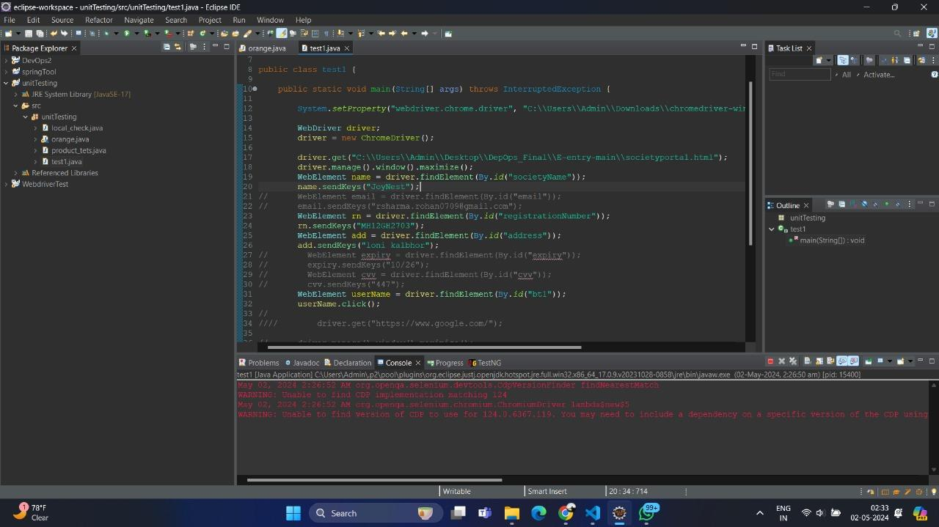

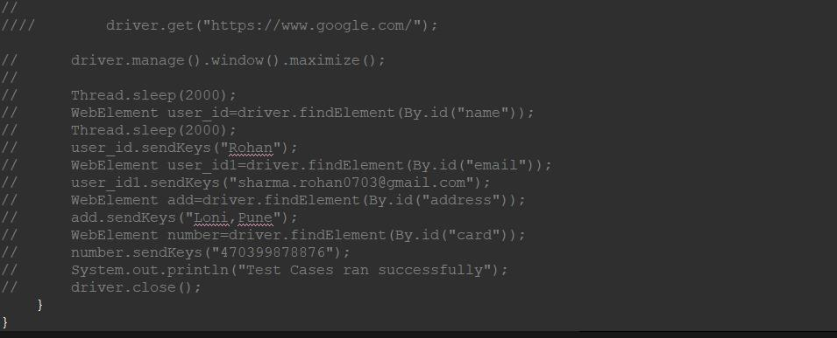

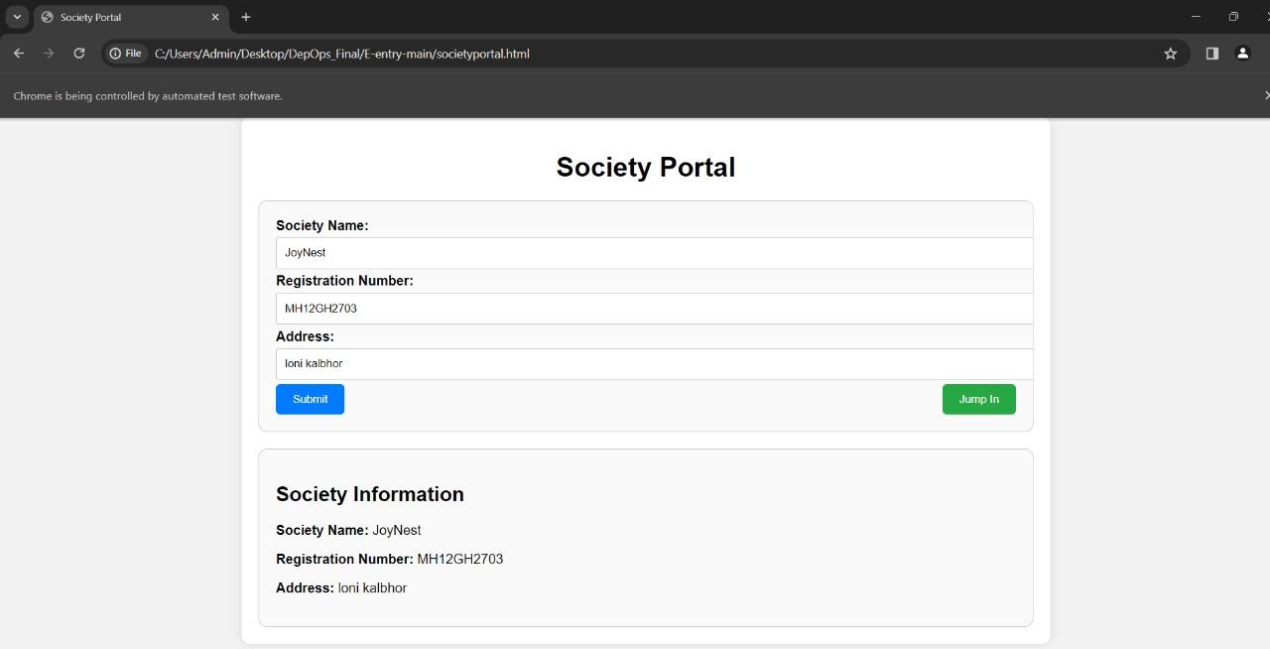

Task 4: Utilize Docker and Kubernetes for containerization and orchestration of the application.

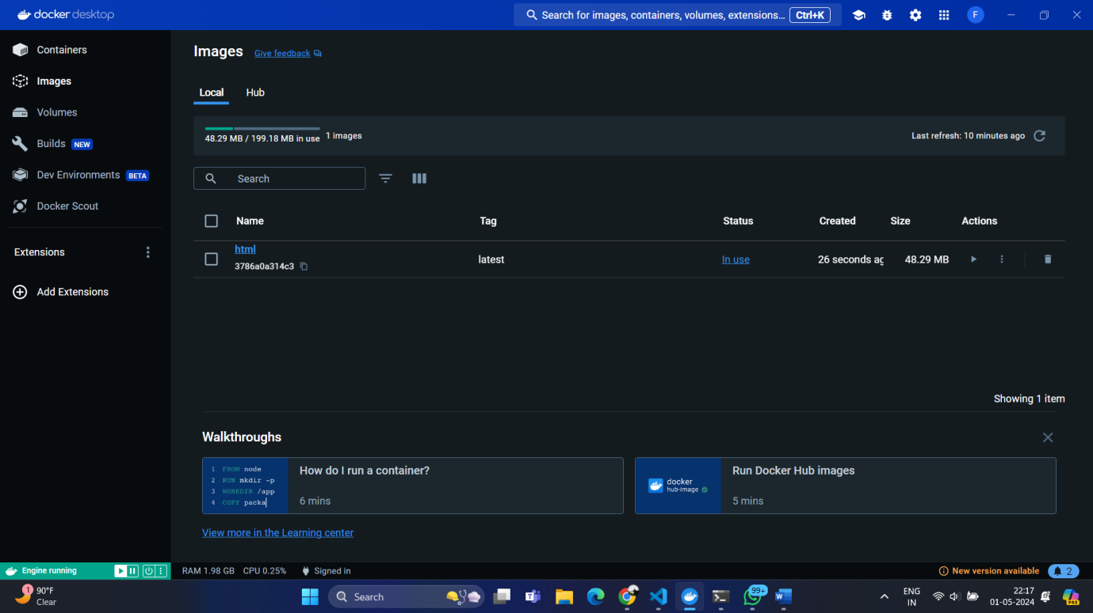

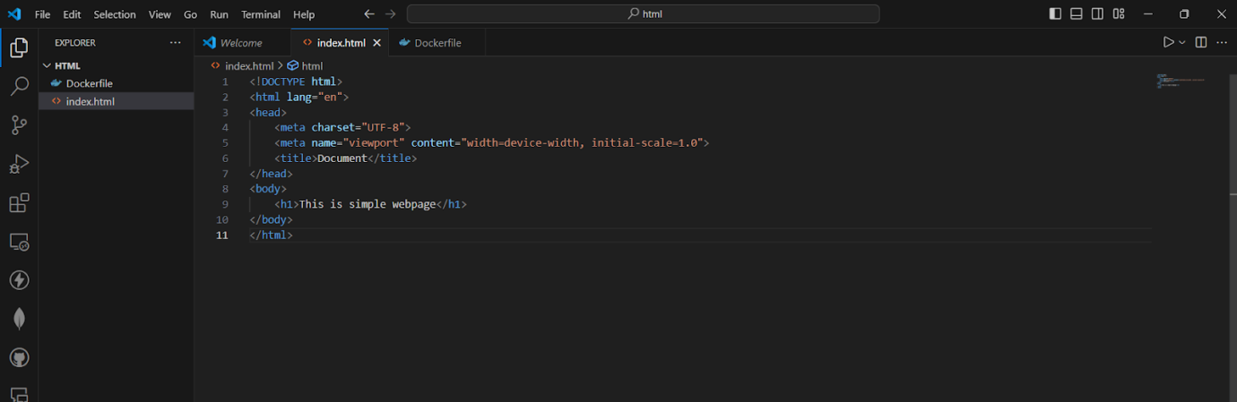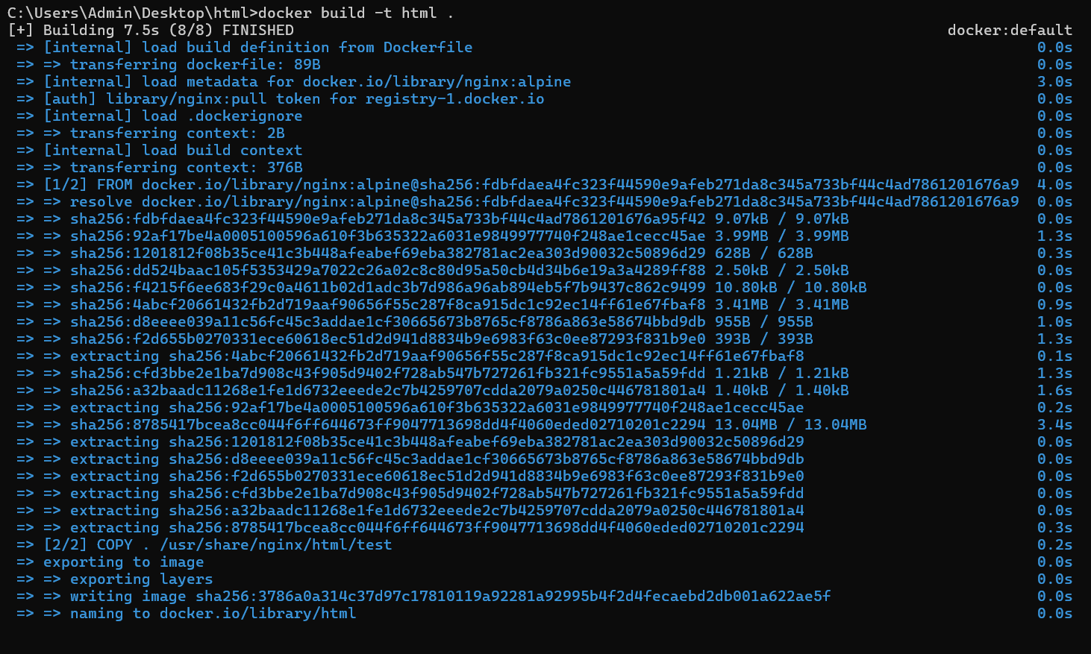

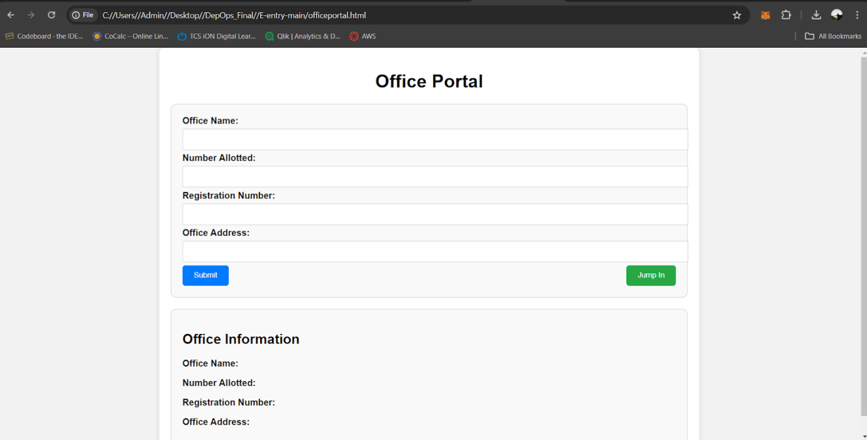

Report:

Overview:

Integrating Docker with a CI/CD pipeline involves automating the process of building Docker images, running tests, and deploying containers whenever there's a new code change. Here's how you can do it:

1. Choose a CI/CD Platform: There are several CI/CD platforms available, such as Jenkins, GitLab CI/CD, Travis CI, CircleCI, and GitHub Actions. Choose one that integrates well with Docker and GitHub.

2. Configure CI/CD Pipeline: Set up a pipeline configuration file in your repository (e.g., `.gitlab-ci.yml`, `Jenkinsfile`, `.travis.yml`, `.circleci/config.yml`, or `.github/workflows/docker.yml` for GitHub Actions). This file will define the stages of your CI/CD pipeline, including building Docker images, running tests, and deploying containers.

3. Define Docker Build Stage: In your pipeline configuration file, define a stage for building Docker images. This stage should use the `docker build` command to build your Docker image based on the `Dockerfile` in your repository.

4. Run Tests: If you have automated tests for your application, include a stage in your pipeline configuration file to run these tests. This ensures that your Docker image meets the required quality standards before deployment.

5. Push Docker Image : After building the Docker image and running tests successfully, push the image to a Docker registry (e.g., Docker Hub, GitHub Container Registry, or a private registry). Use the `docker push` command in your pipeline configuration file to accomplish this.

6. Deploy Docker Container: Depending on your deployment strategy, include a deployment stage in your pipeline configuration file to deploy the Docker container to your target environment (e.g., staging or production). You can use tools like Kubernetes, Docker Swarm, or Docker Compose for deployment.

7. Trigger Pipeline on Code Changes: Configure your CI/CD platform to trigger the pipeline whenever there's a new code change pushed to your GitHub repository. This ensures that your pipeline automatically builds and deploys the latest version of your application.

8. Monitor and Debug: Monitor the CI/CD pipeline to ensure it runs smoothly and troubleshoot any issues that may arise. You can set up alerts and notifications to stay informed about the pipeline's status.

By integrating Docker with your CI/CD pipeline, you can automate the process of building, testing, and deploying your applications, leading to faster and more reliable software delivery.